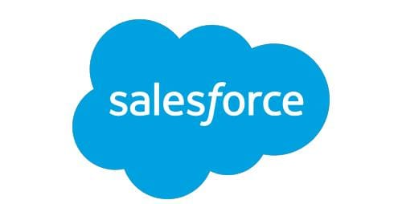

**Salesforce Project Ready**

Entry level Training & Professional Development Program

**Project title : College management application**



**Day 1 :**

**Topic :** Introduction about sandbox and In object manager explained fields and relationships

**Milestones / Activities :**

About sandbox and fields and relationships

**Detailed Description :**

**About Sandbox :**

Sandbox - identical copy of your production, metadata, data.

* production org - live data, -> create sandbox
* Certain type of sandbox in given below

1. Developer Sandbox
2. Developer Pro sandbox
3. Partial copy sandbox
4. Full copy sandbox

**1- Developer sandbox -**

Identical copy of production it doesn't hold any live data. data space - 200mB refresh interval 1 time in a day

**2- Developer Pro sandbox -**

Data size 1GB, it is designed for a group of developers. developer, testing, and interpretation testing as well refresh interval - 1 time in a day

**3- Partial copy sandbox -**

This is copies your configuration and some (not all) of your data, so you can test new configurations with your own real data. Unlike a Full Sandbox, which copies all of your data and is a complete clone of your production organization, a Partial Copy Sandbox



only copies a selection of your data.

datasets - 5gb each object can hold 10,000 records refresh interval - 1 time in every days. pulk load, UAT environment

**4- Full copy sandbox -**

exact copy of your production environment

datasets - similar as production. refresh interval - 1 time in every 29 days

**Object manager :**

In this object manager having some of the objects. The object is named as records and its each record is associated with objects. Like Account, Opportunity, Contact etc..

In the object manager having two types of objects -

* Custom object
* Standard object

The custom object is objects that you create to store information that's specific to your company or industry.

The Standard object is objects already created for you by the Salesforce platform.

In the object manager having some field and relationships :

Fields are an integral part of record creation. They are used to store different attributes of the same object or an entity.

Relationship to explain the relation between objects

The detailed explanation is given below

There are majorly two categories of fields in Salesforce. Firstly we have Standard Fields which are prebuilt in salesforce. Even though we have the privilege of editing this field but in no way it can be delete. Next, let’s also have a look at Custom Fields. These fields 

are defined by us i.e. the user which can either be used to extend the functionality of a standard object or add fields to our custom objects.

**Field Creation :**

The first step at field creation involves selection of its data type. It tells us about the kind of information the field stores. Some of the common data types we might run into includes Checkbox, Date, Text, Number etc.

**Unique Fields:** Fields can be made unique which would impose no duplicate records to be entered. For example an email field.

**Required fields:** This field makes it mandatory for a value to be added at record creation. It cant be null. For example: Phone number.

**External ID:** Used to identify the records uniquely from the external system. For example while importing data from excel sheet to salesforce this field comes in handy.

The table below lets us know about the types of fields we will come across in Salesforce.

|  |  |
| --- | --- |
| FIELD TYPE | DESCRIPTION |
| Identity | Case-sensitive, 15 character field which gets generated for every record. Example: 50130000000014c |
| System | Read-only fields which give information about a record from the system. Example:CreatedDate, LastModifiedById, LastModifiedDate. |
| Name | Text names or auto-numbered names which increment upon record creation. This field is required. |



Overview of Field level security : Field level security in salesforce controls visibility, accessibility and manipulation for a particular field on an object. It can be applied to multiple fields on a single profile or permission set and can also be applied to a single field on all profiles.

**Field Dependencies** **:** They are the filters which allow us to change the contents of a picklist based on the value of another field. City and state is a good example of field dependency where city will be the dependent field and state will be the controlling field.

**Relationships** **:** Similar to the concept of relationships that we studied in RDBMS which was introduced to remove data inconsistency and data redundancy, Salesforce also provides us the same concept which can be implemented using Relationship fields.

The certain relationships is given below

1. Lookup relationship
2. Master details relationships
3. Self relationship
4. Many to many relationship
5. Indirect relationship

**Lookup relationship :** These share weak association among the two associated objects.

**Master detail Relationship :** It represents a strong relationship between a master and a detail object. Detail records cannot exist without a master record. Detailed objects inherit the security and sharing settings of master objects. Example: Multiple Employees can be associated with a company

**Self relationship :** When an object has a lookup with itself, it is a self-relationship. A self relationship creates a tree diagram of the objects. For example, the account has a lookup on himself, called Parent Account.



**Many to many relationship :** Using a custom junction object, you can model a “many-to-many” relationship between two objects. For example, you create a custom object called “Bug” that relates to the standard case object such that a bug could be related to multiple cases and a case could also be related to multiple bugs.

**Indirect relationship :** It is a new field type introduced with Salesforce Connect. It links an external object to a standard or custom object in the same way that a regular lookup relationship links standard or custom objects.

**Overview of Field level security :**

Field level security in salesforce controls visibility, accessibility and manipulation for a particular field on an object. It can be applied to multiple fields on a single profile or permission set and can also be applied to a single field on all profiles.

**Snapshots of the Milestone and Activities** :

sandboxes selection and its environment :



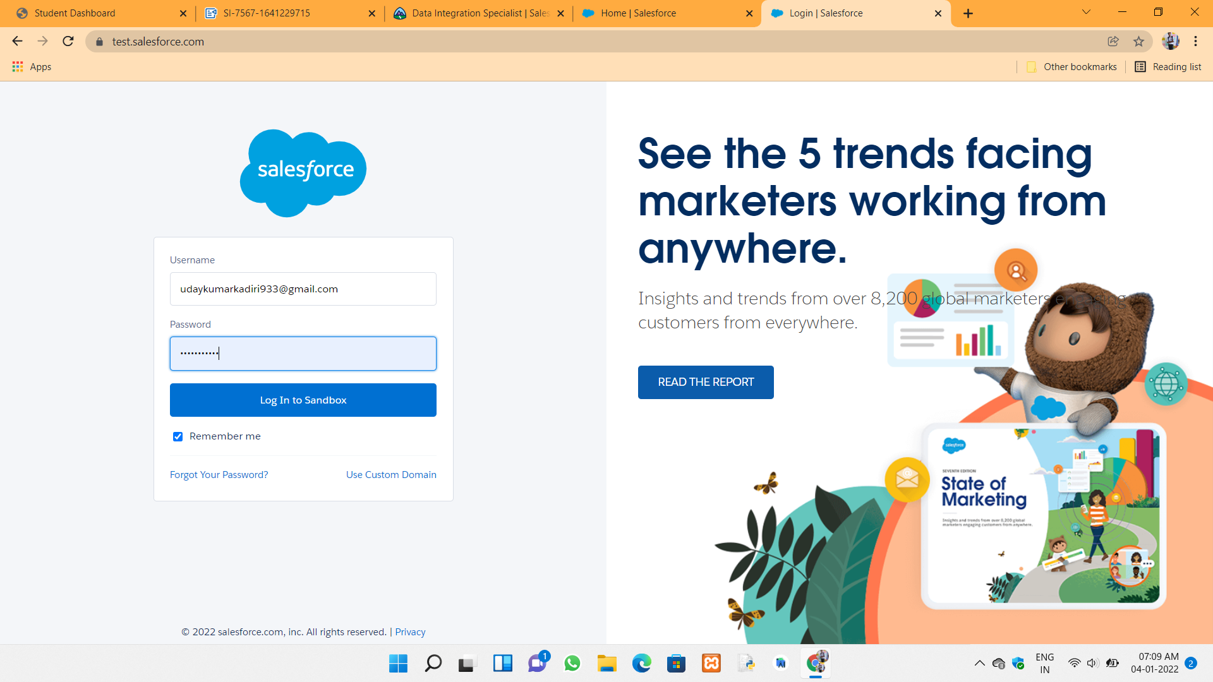

object manager types :

Custom object:

Standard object :



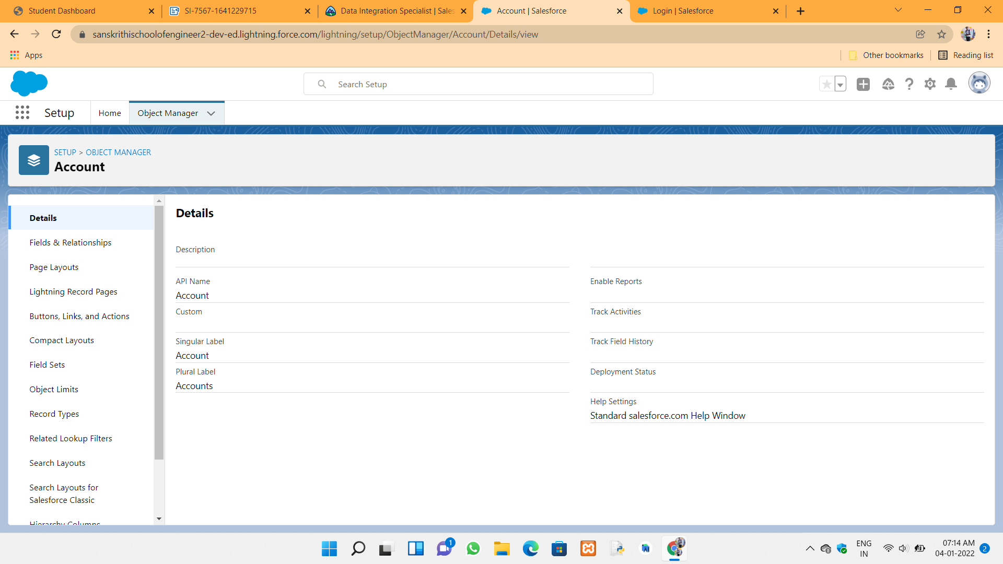

Fields and relationships in salesforce page :

Custom fields :



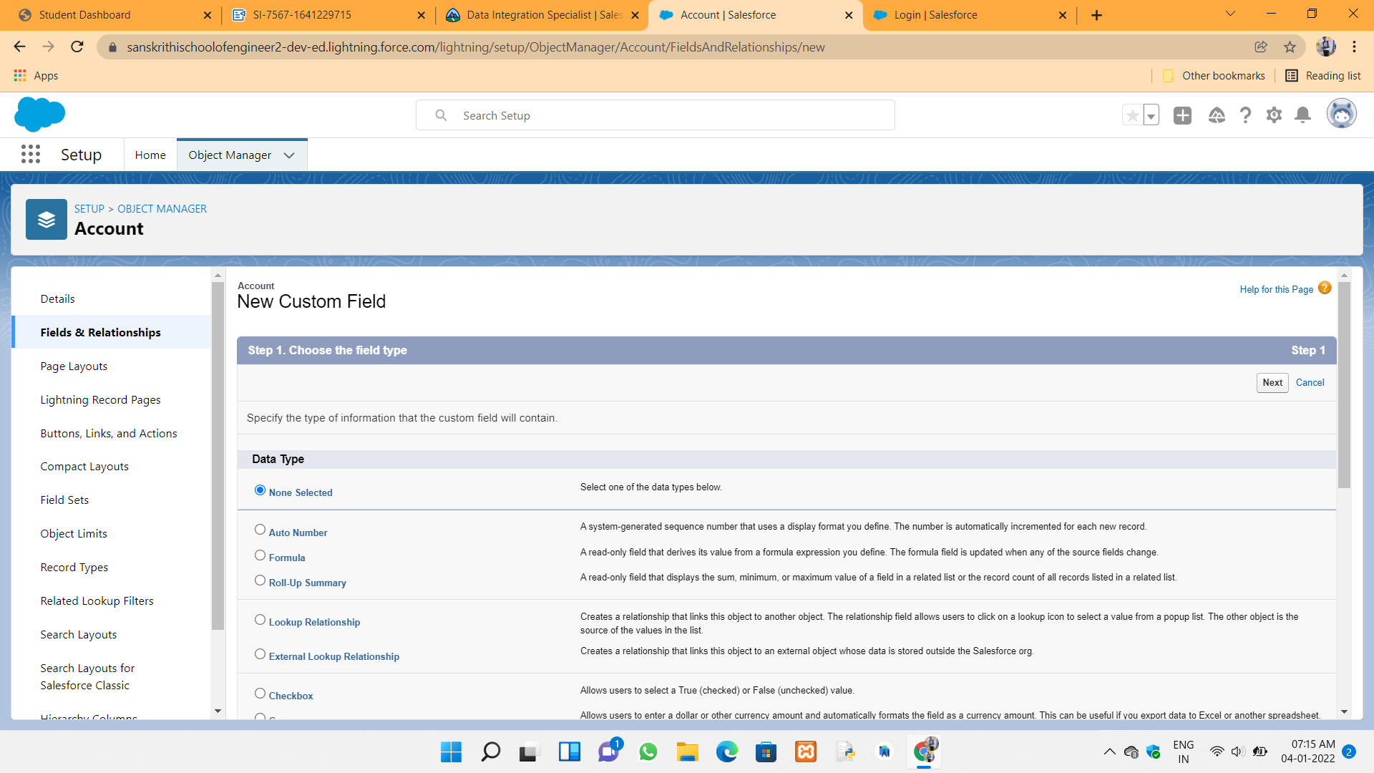

Relationships :



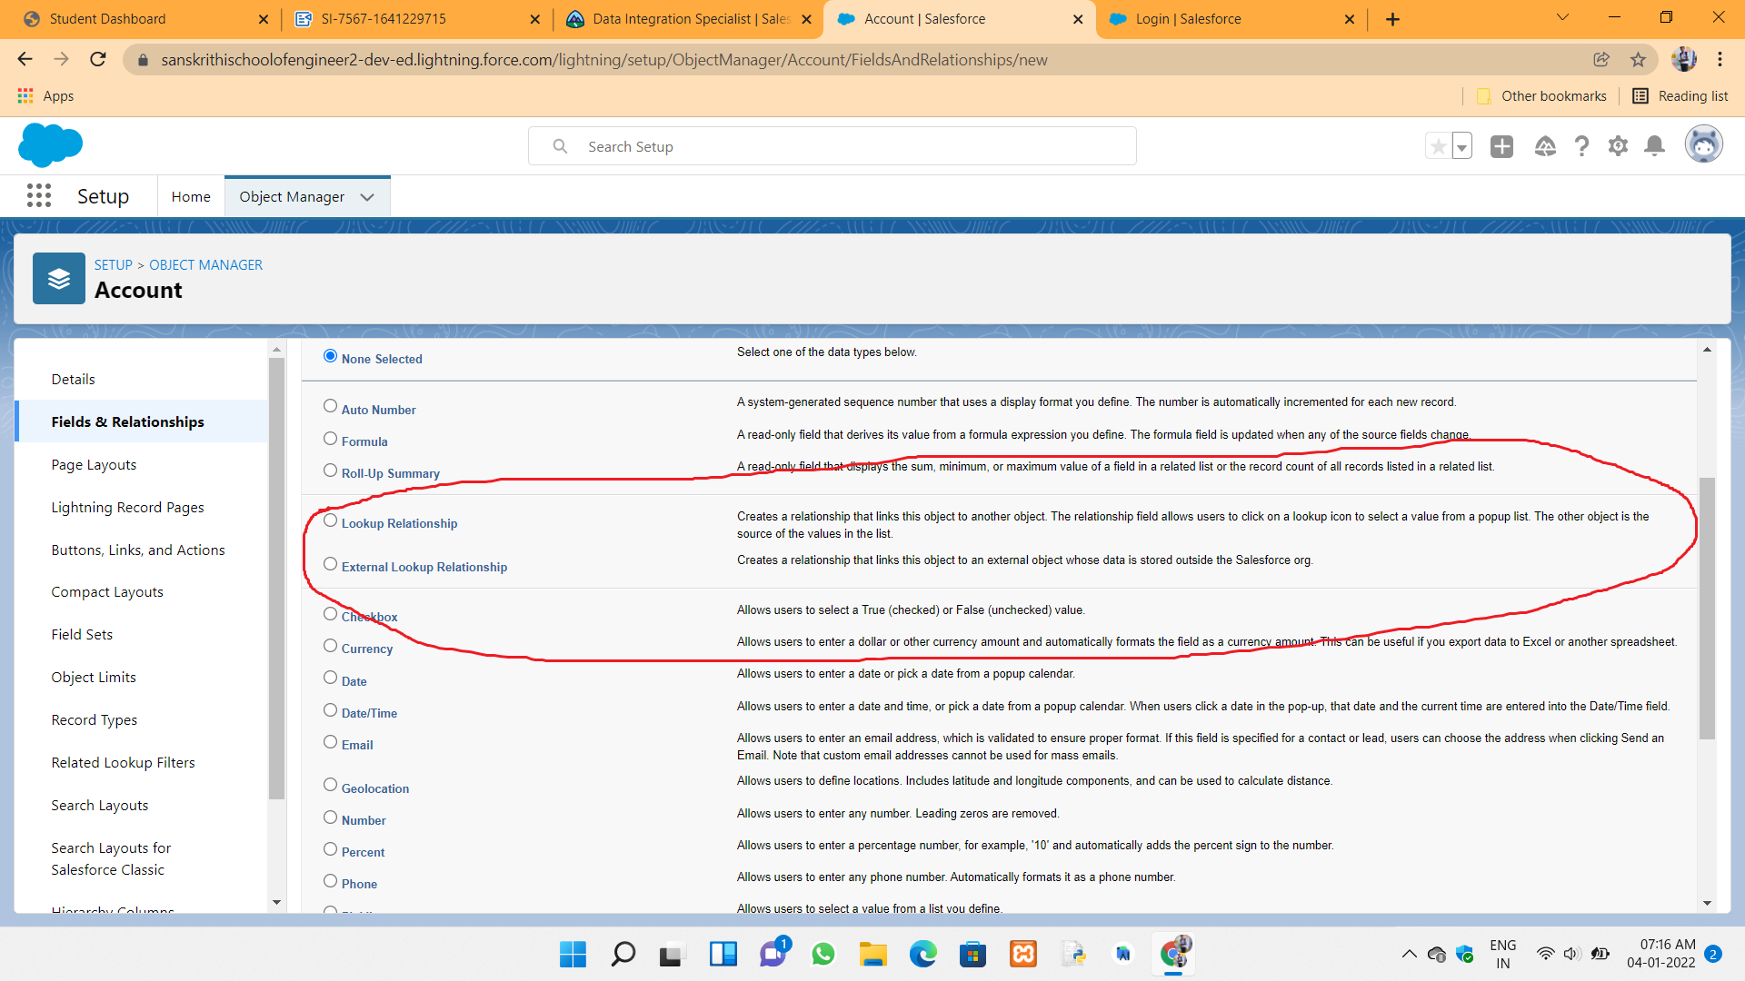



**Day 2 :**

**Topic :** Created developer account and log in to the my organization and Create the college management application and its attributes

**Milestones / activities :** App manager through create the college management application. Object creation and field creation and validation rules and page layouts added into the college management application.

**Detailed Description :**

**App manager:**

App manager is used to for managing apps for Lightning Experience. When you edit a Lightning app from the App Manager in Setup, you’re brought into the Lightning App Builder to manage the app’s settings. Update app branding, navigation, and other options, and manage the Lightning pages assigned to that app all in one place.

Setting First App:

To setup a default app per profile we should follow the instructions that I have given below:

1. From Setup, enter App manager in the Quick Find box, then select App manager  
2. Select a New lightning app at the top of the page.  
3. An empty new lightning app page is displayed.  
4. Enter Corresponding details in that page as per user requirements and click save and next.

5. App options page will displayed and enter corresponding details and click next.

6. Now add navigation items and user profiles as per requirements and click next.

7. click Save.

**Custom Object creation:**

The custom object is an object that which we create to store an information specific to user requirements.

To create custom object follow the instructions that I have shown below:

1.Click on object manager in setup page.

2. On the top of the page we will see that create menu so that we can create custom object as per requirements

3. click save

Create custom Tabs:

1. From Setup, enter Tabs in the Quick Find box, then select Tabs.
2. A Tabs page is displayed.
3. Now click new button near create custom tab so that custom tab will be created
4. Now create a tab with respective object and select Tab style in requirements
5. click next and save

Now college Tab will be set in College management application. So that you will be create new fields in that college.

Picklist value sets:

Picklist value sets are used to finds all the values in the database for the Industry field or any other object.

To Create picklist value sets follow the instructions given below:

1. From Quick find box, search picklist value sets and click on it
2. Open custom picklist value sets in that page
3. Enter a label for the global value set. This name appears in Setup, and when users create a picklist based on this global value set.
4. To tell users what these values are for, enter a specific description of the global value set. This text appears on the Picklist Value Sets list page in Setup.
5. Enter the values, one per line.
6. Optionally choose to sort the values alphabetically or to use the first value in the list as the default value, or both.
7. Click Save.

**Field Creation:**

We can create Many fields in every object. To create fields we have to follow the steps given below.

1. Open object manager and click particular object where you have to create fields.
2. Click Fields and relationships in that object.
3. Click on "New" to create new fields
4. Enter corresponding details regarding to that and click next
5. click save

Now that field is successfully created

**Snapshots of the Milestone and Activities** :

Creating Developer account in salesforce :

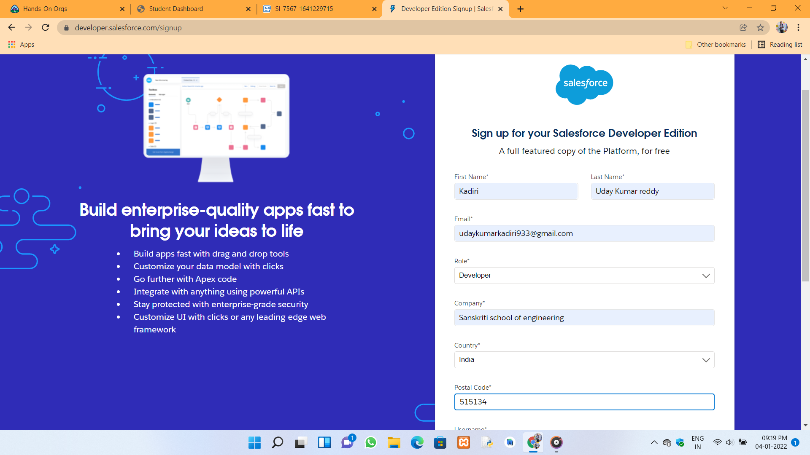

My organization :



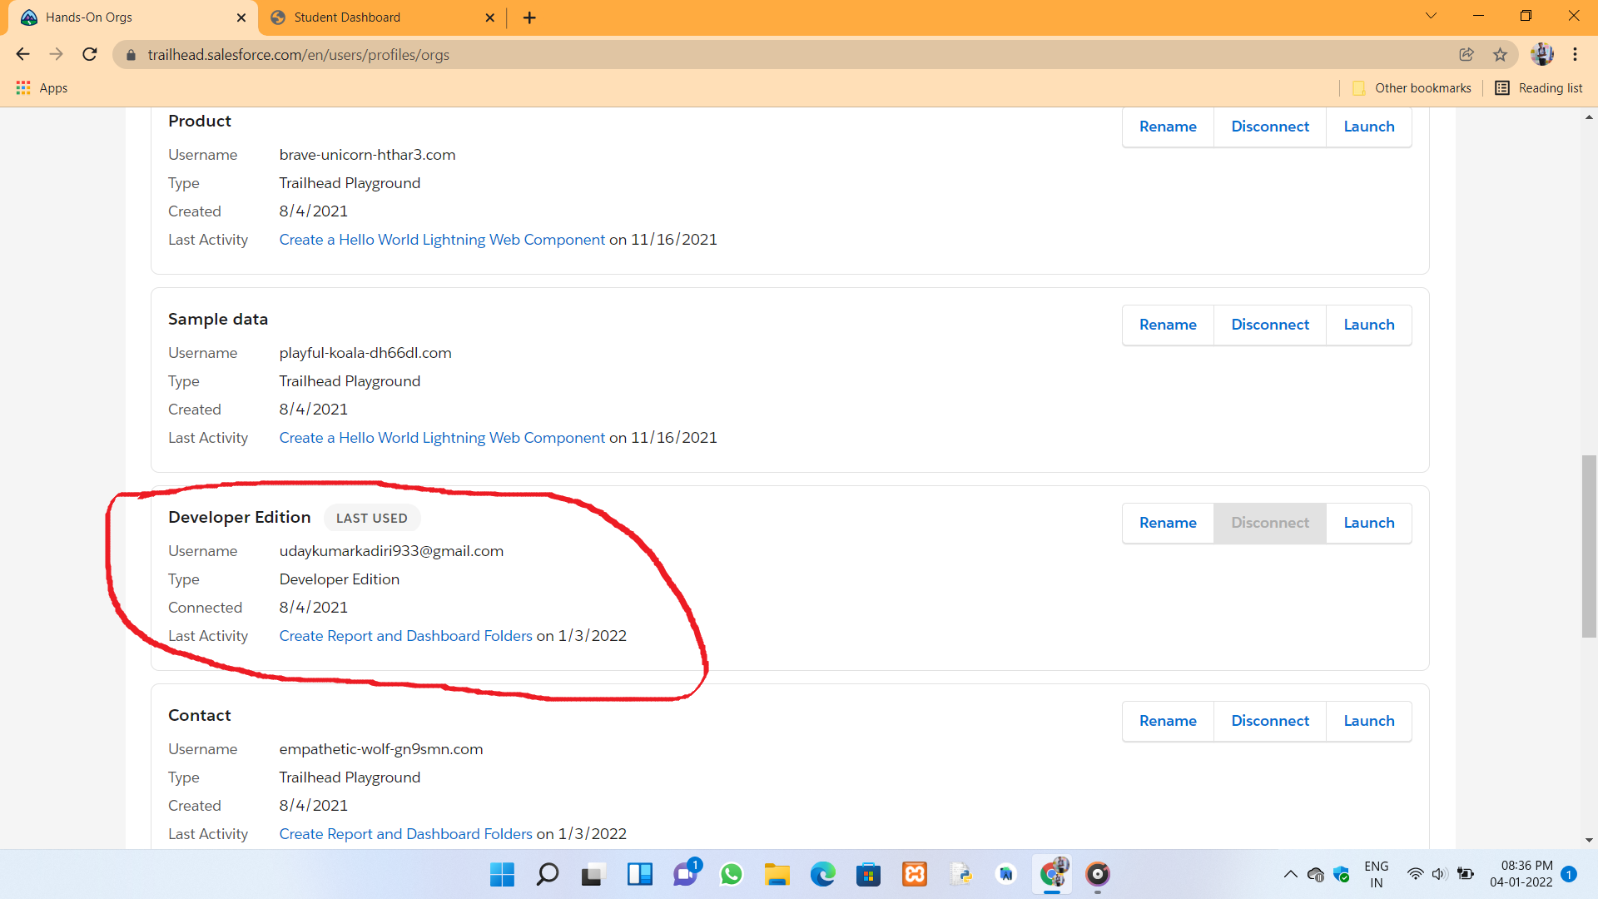

App manager to create College management application :



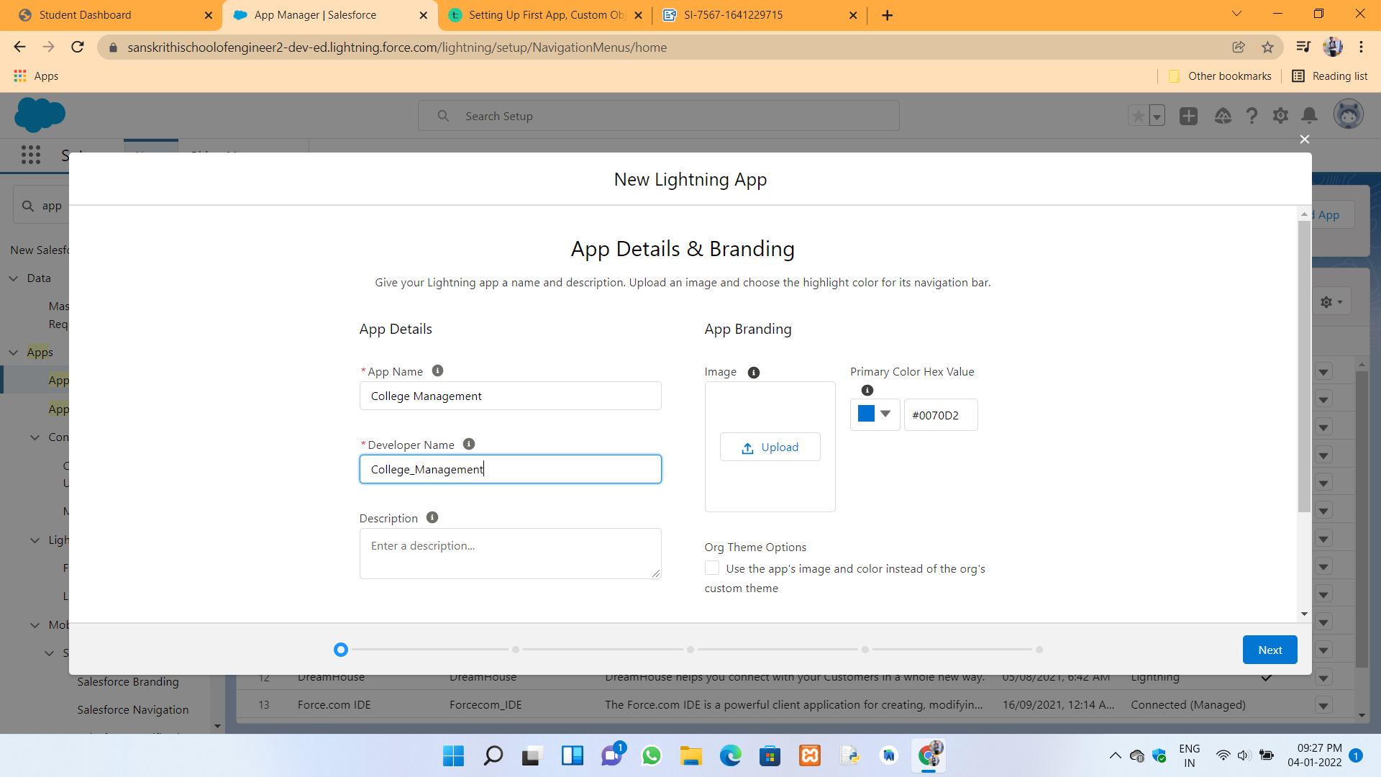

Custom objects to create in the College management :

College object



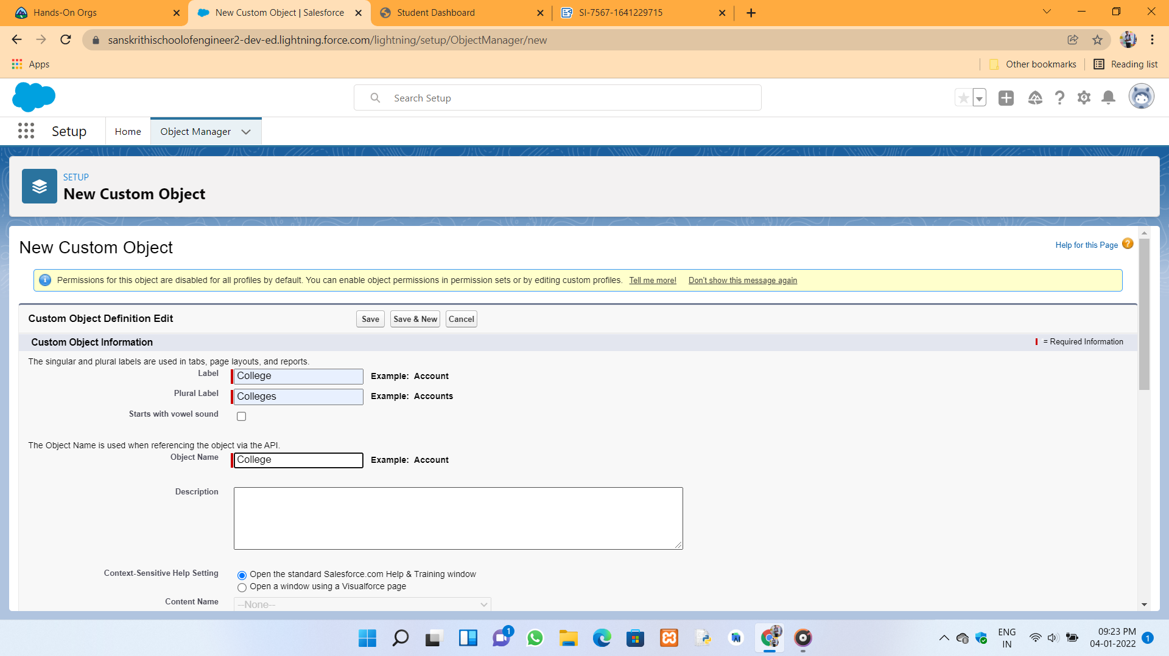

Application form object :



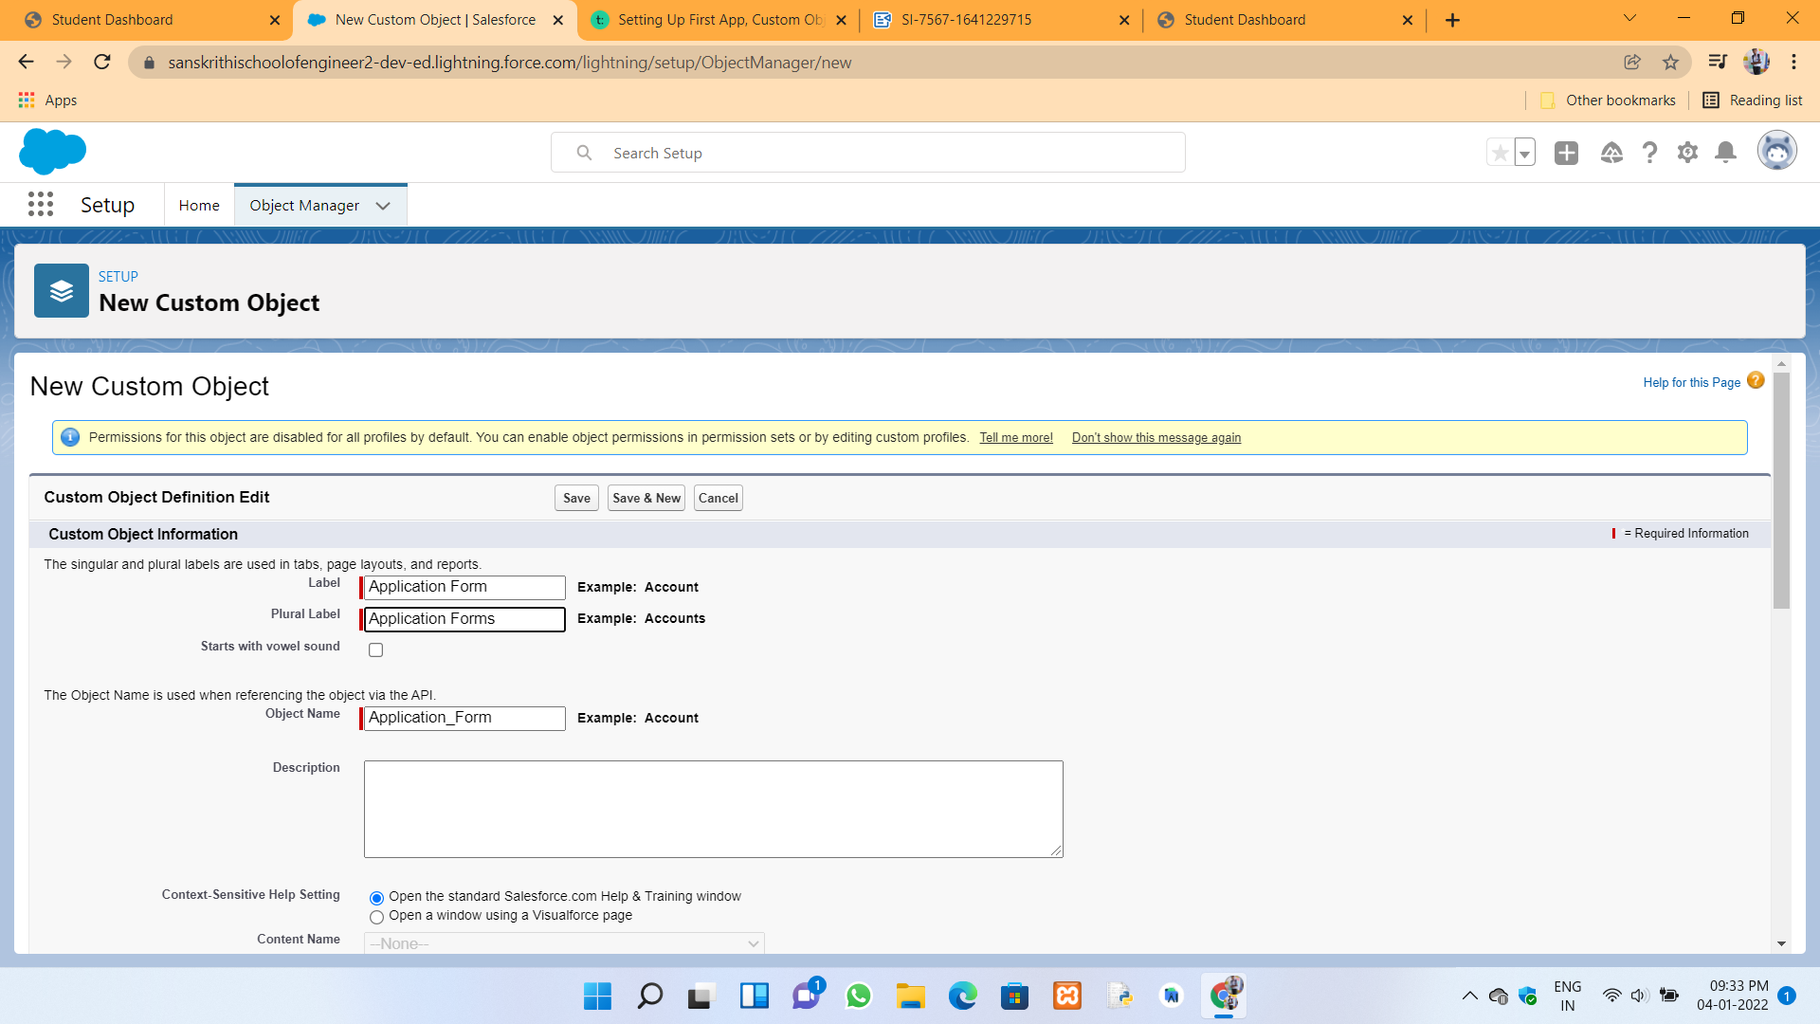

Student object in application form and application form object:



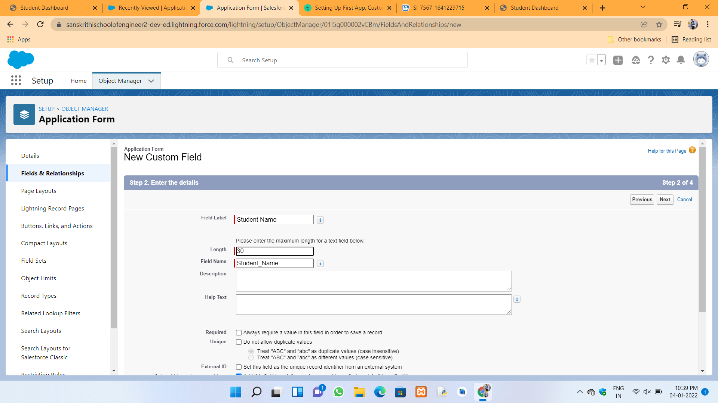

Date of Birth in Application form object :



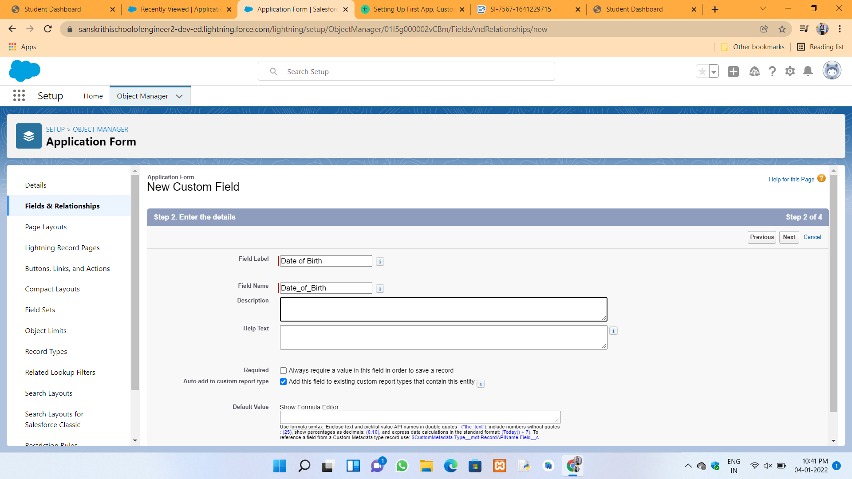

Record info field in College object and application form object:\



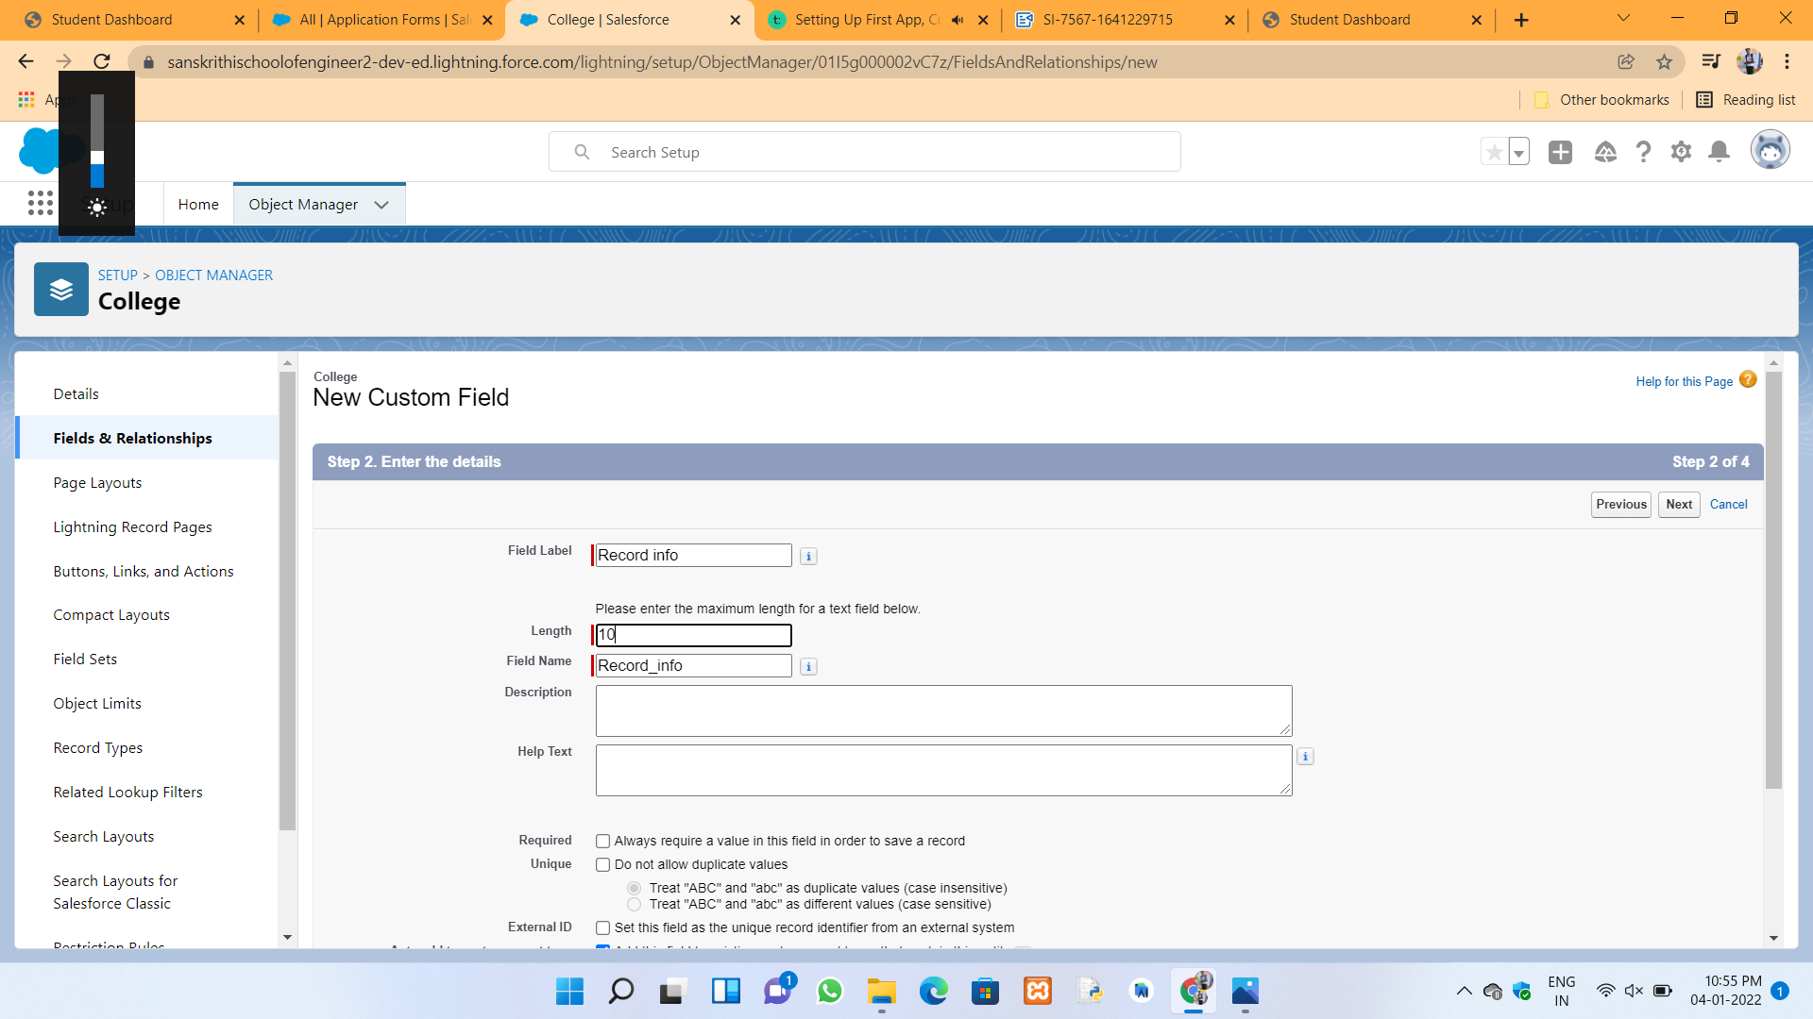

College fees field in College object and application form object:



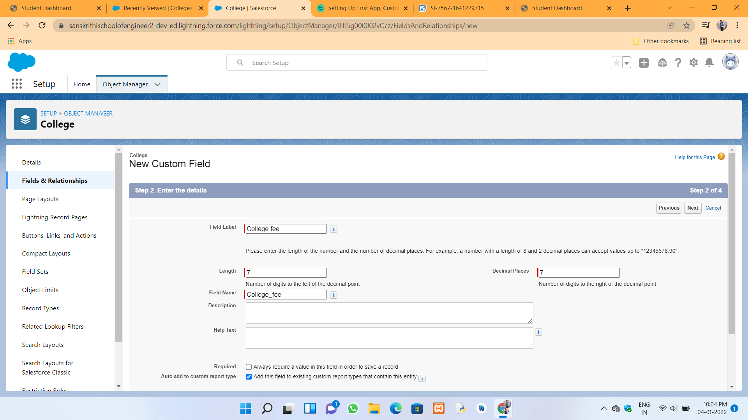

Hostel fees field in College object and application form object:



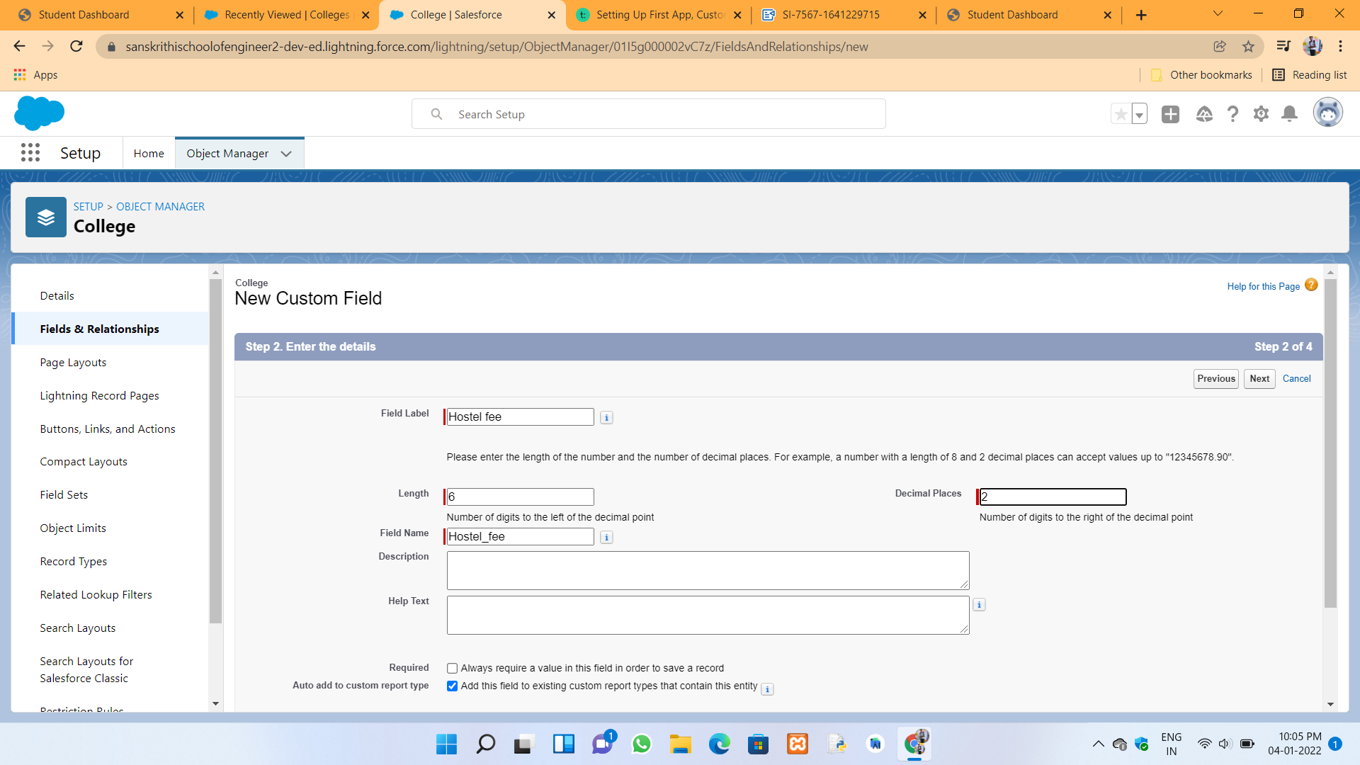

College Name Picklist in College object and application form object :



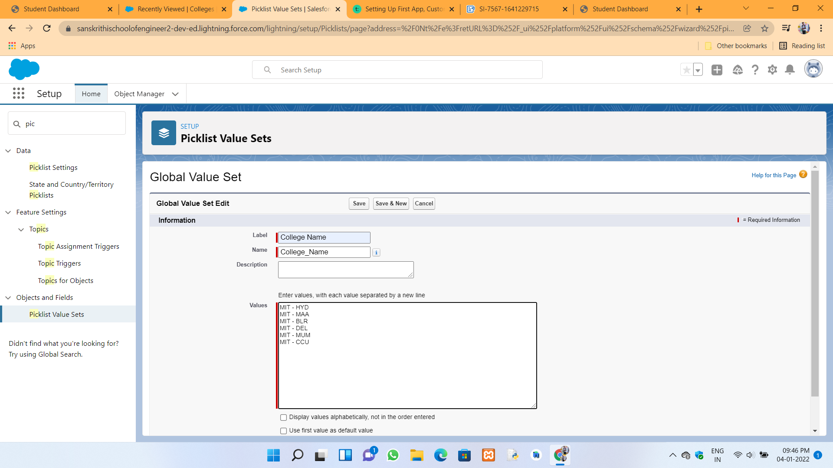

College Email picklist in College object and application form object:



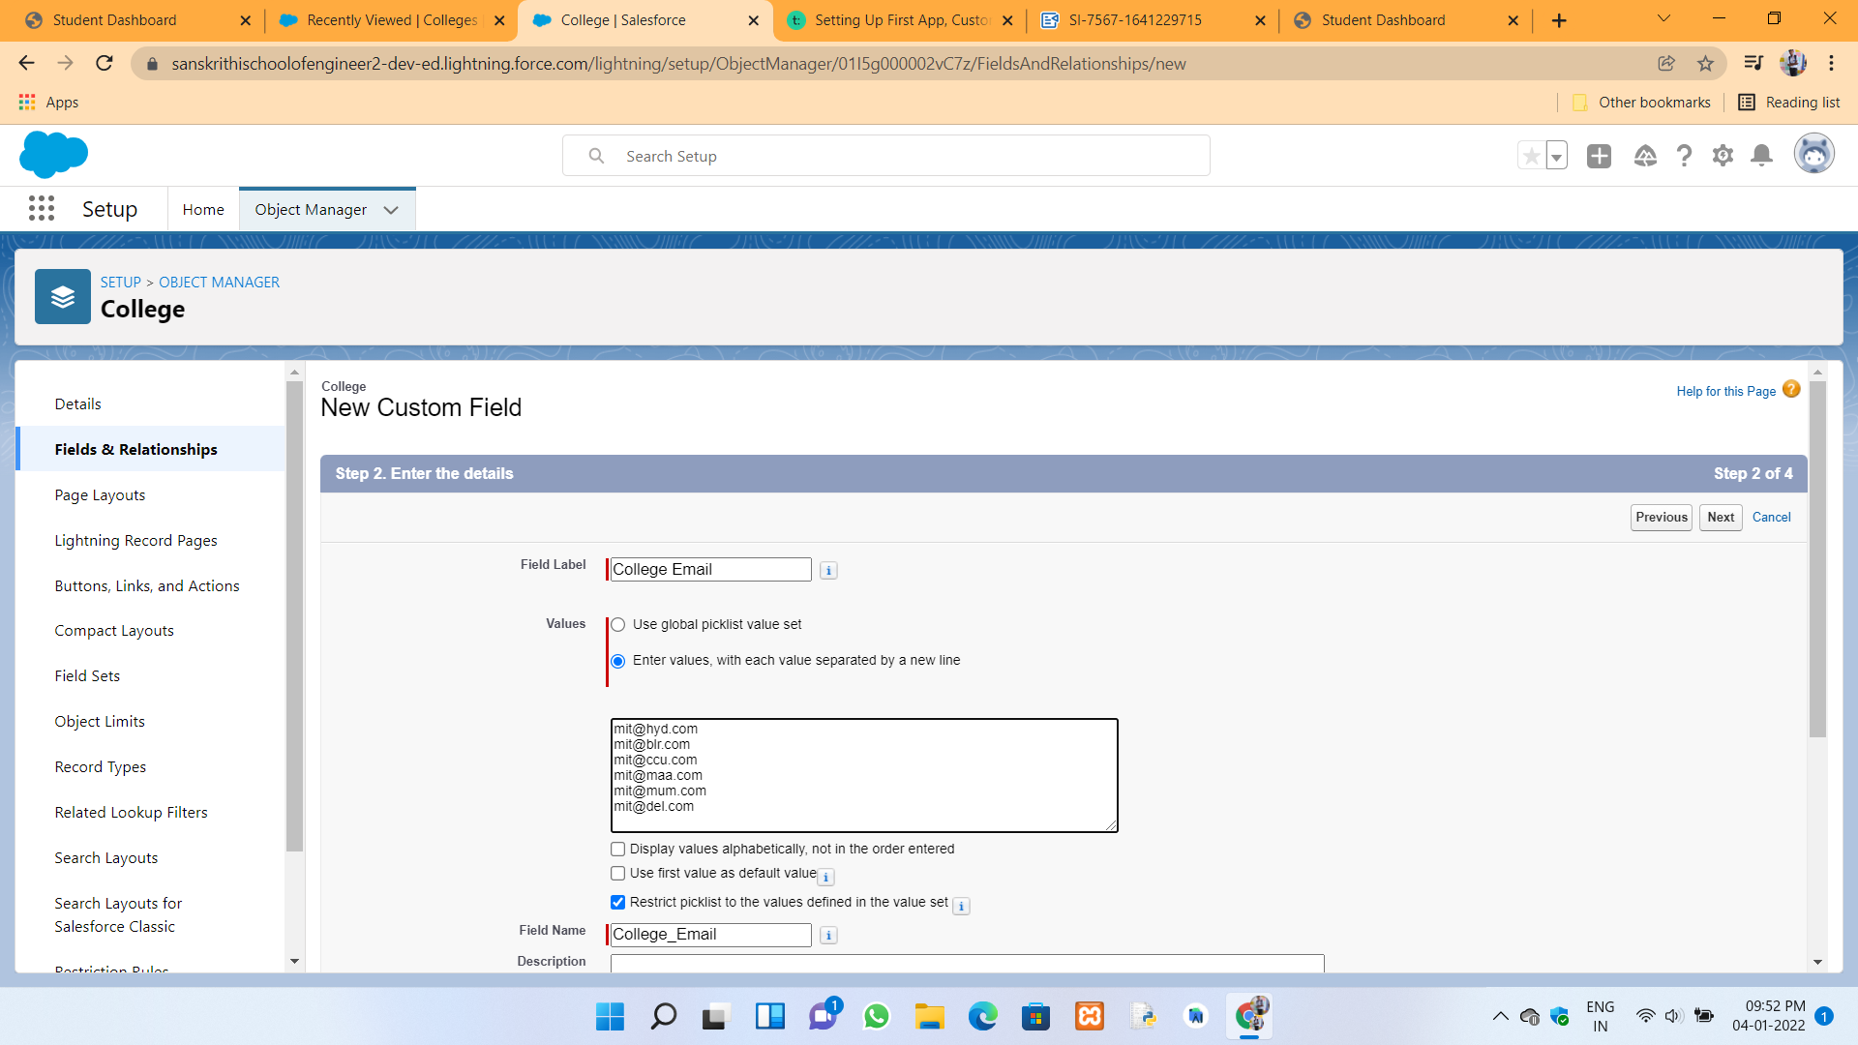

Capacity of students in college picklist in College object :



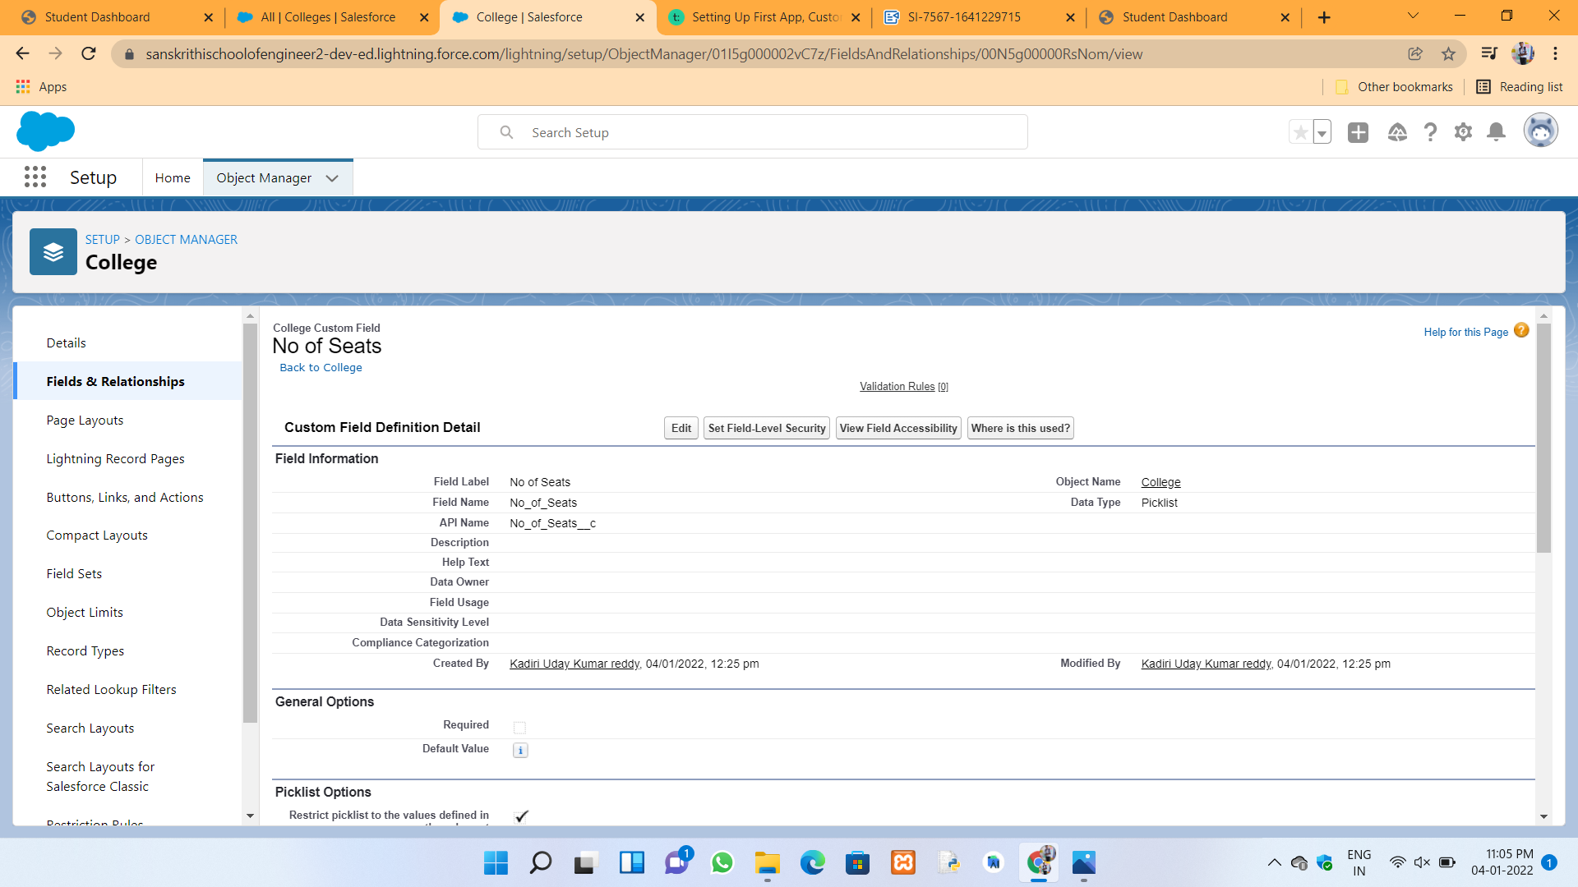

Field dependencies between College name and college email :



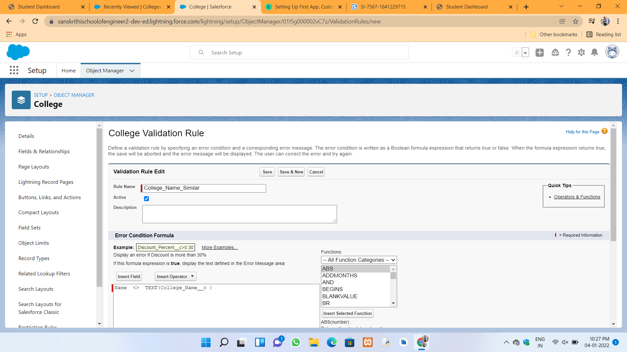

Field dependencies between college name and capacity of students :



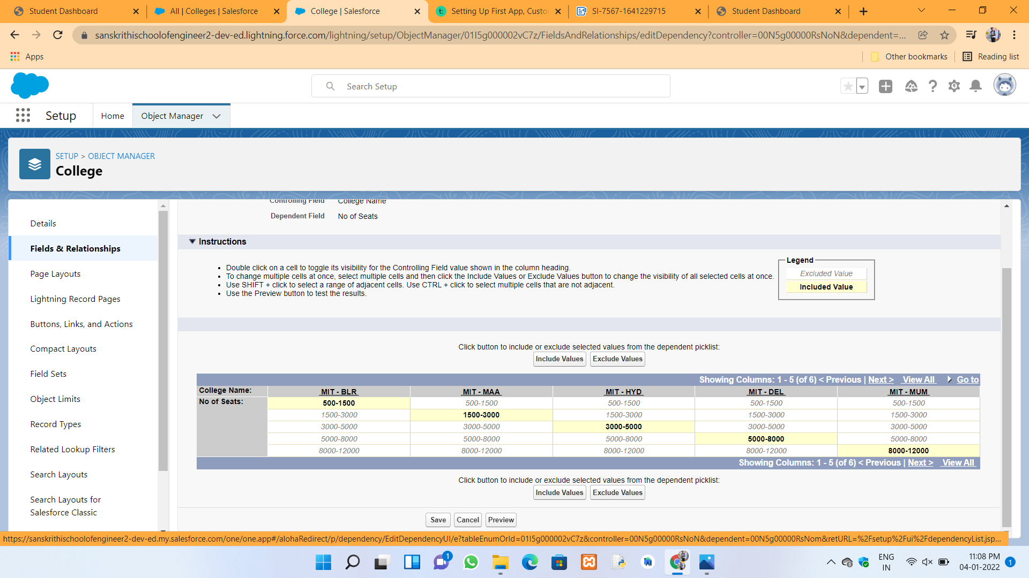

College object fields and relationships :



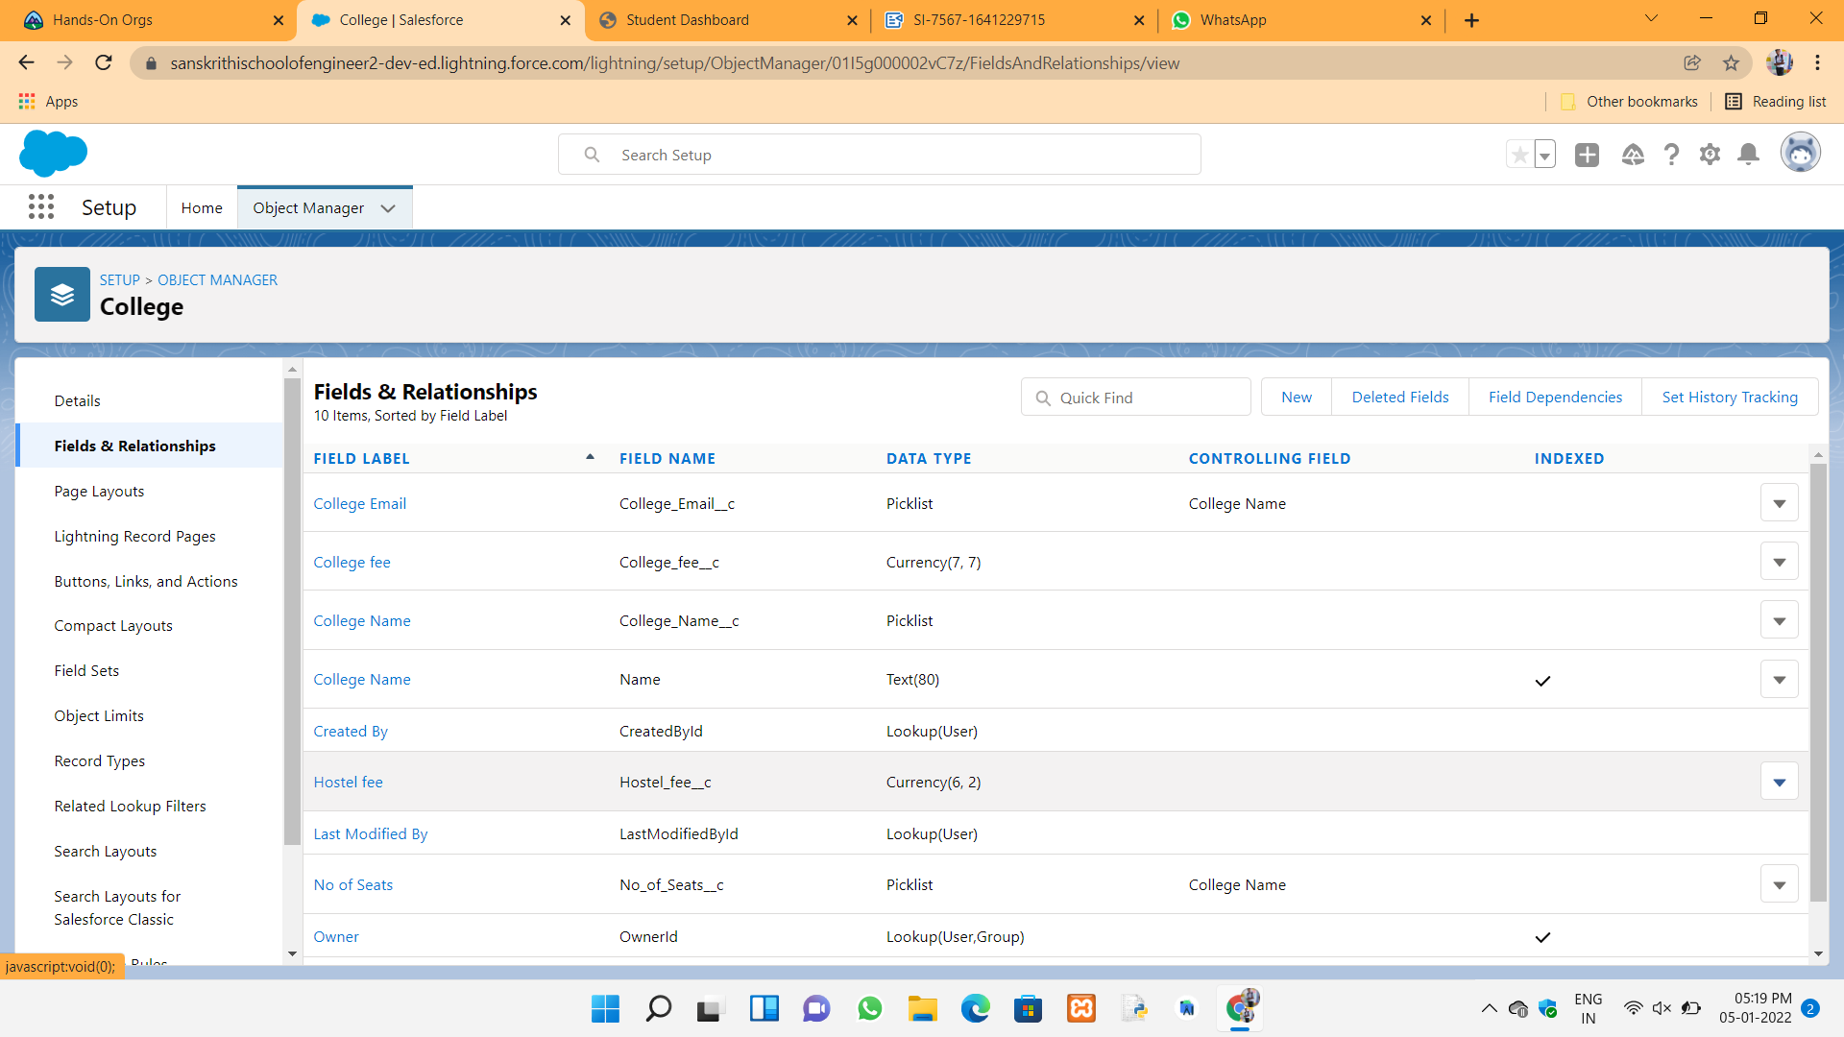

Application form fields and relationships :



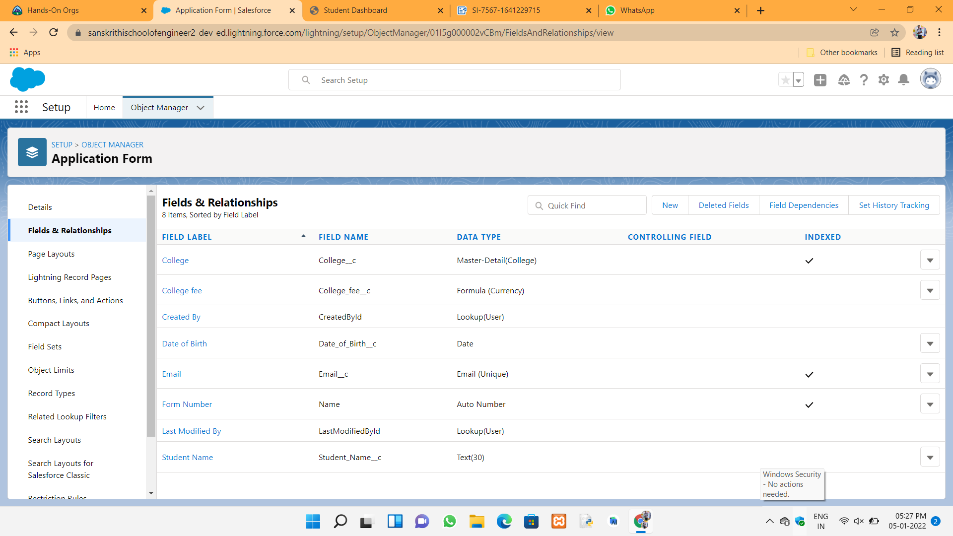

College management application overview all things :



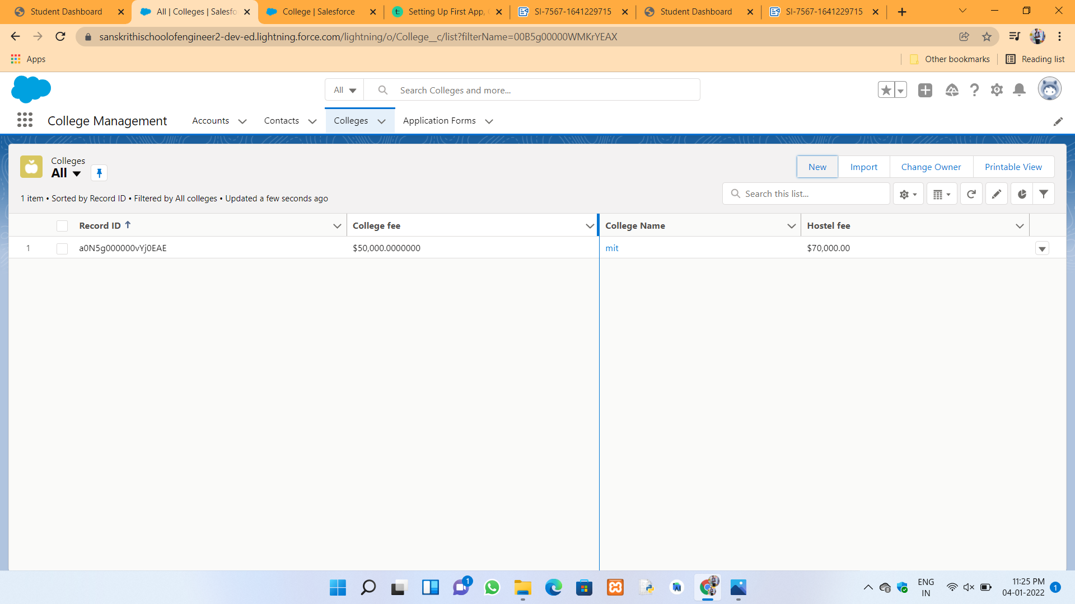



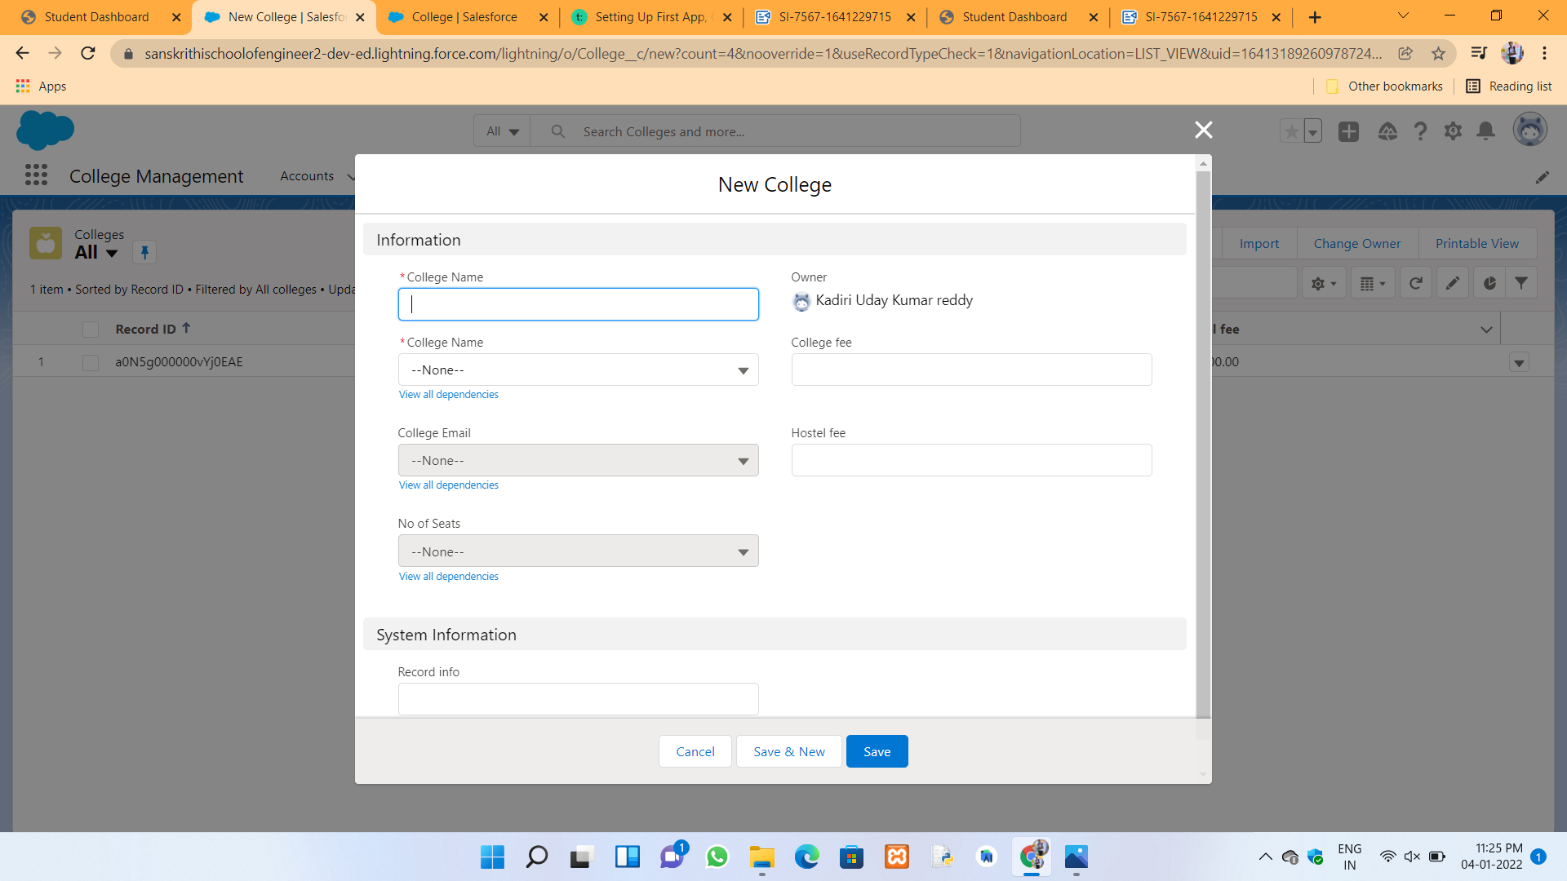

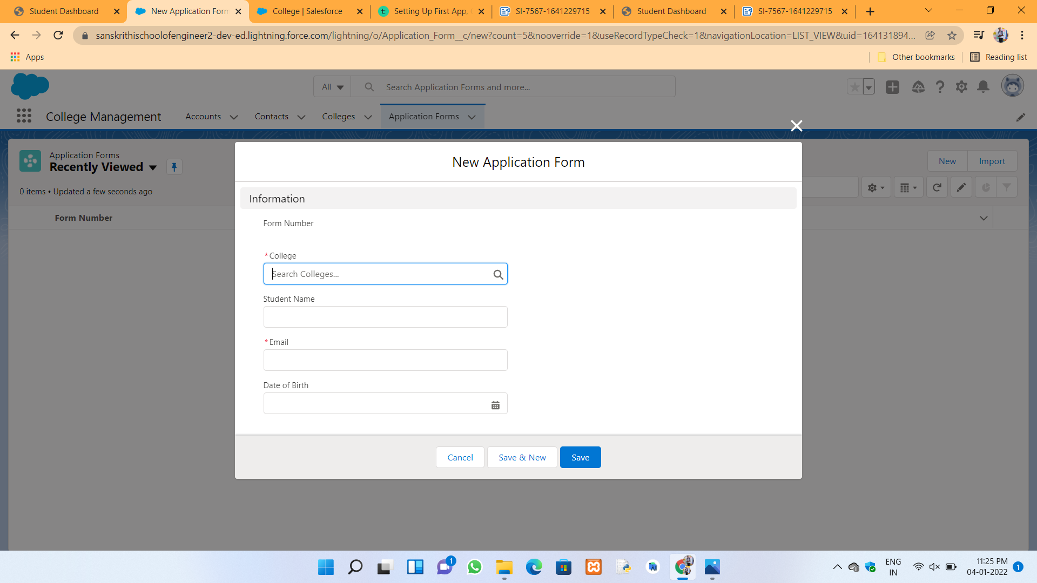



**Day 3 :**

**Topic :** In college management application to add custom objects and give the permissions to the system administrator and adding the business logic and automation and email templates.

**Milestones / Activities :** Creating the custom objects and give the permissions to users and add business logic and automation and email templates.

**Description :**

**Student object to create as a custom and in this object to create some fields. This are given below:**

|  |  |
| --- | --- |
| Student Name | Text |
| Address | Text(255) |
| Application Form | Lookup(Application Form) |
| College Name | Formula(Text) |
| Date Of Birth | Date |
| Guardian Name | Text(30) |
| Phone | Phone |

**Subject object to create as a custom and in this object to create some fields. This are given below :**



Subject ID : AutoNumber

Student : Lookup(Student)

Paper 1 : Picklist(Refer Business Logic Milestone)

Paper2 : Picklist(Refer Business logic Milestone)

**Schema Builder :**

Schema Builder is a tool within Salesforce.com that is used to view and manage objects, fields, and relations between objects in a graphical interface. It is available in all Salesforce.com editions. Schema Builder is not the only option to view and manage objects, fields, and relations between objects.

**Permission give to the profiles and access to the system administrator :**

The Salesforce administrator—or “admin” is a Salesforce user with system administration duties and other super powers. Admins are responsible for setting up Salesforce for their organizations and making sure it runs smoothly. Admins have special permissions.

**Account object to create Saving account and Business account and GST Number :**  
To access this ones in college management application

**Email Templates and related information :**

Email templates with merge fields let you quickly send emails that include field data from Salesforce records like contacts, leads, or opportunities. You can use email templates when emailing groups of people — with list email or mass email— or just one person.



**Snapshots of Milestones / Activities :**

College object fields and relationships :



Application form object fields and relationships :





Student object to create as a custom :



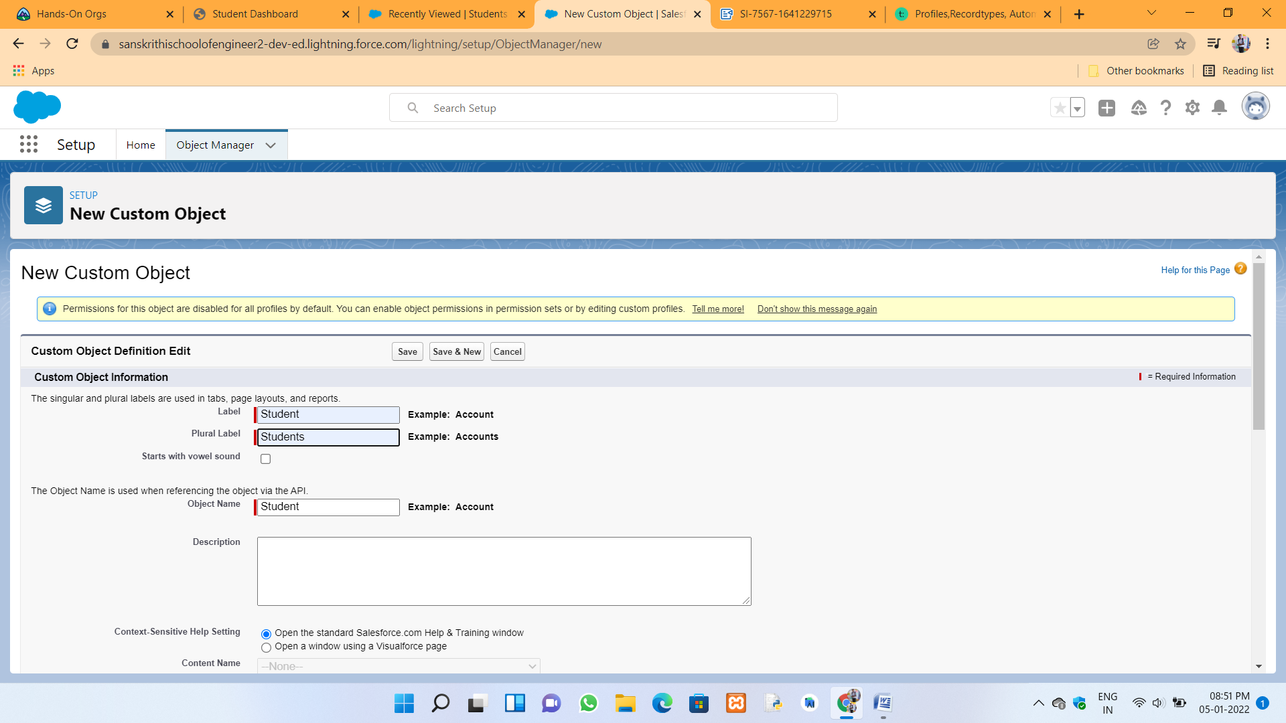

In this custom object to create Student Name field :



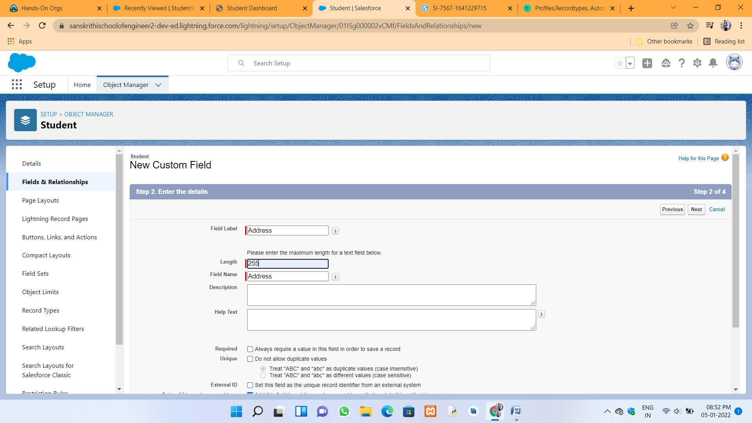

In this custom object to create Address field :





In this custom object to create Application Form field :



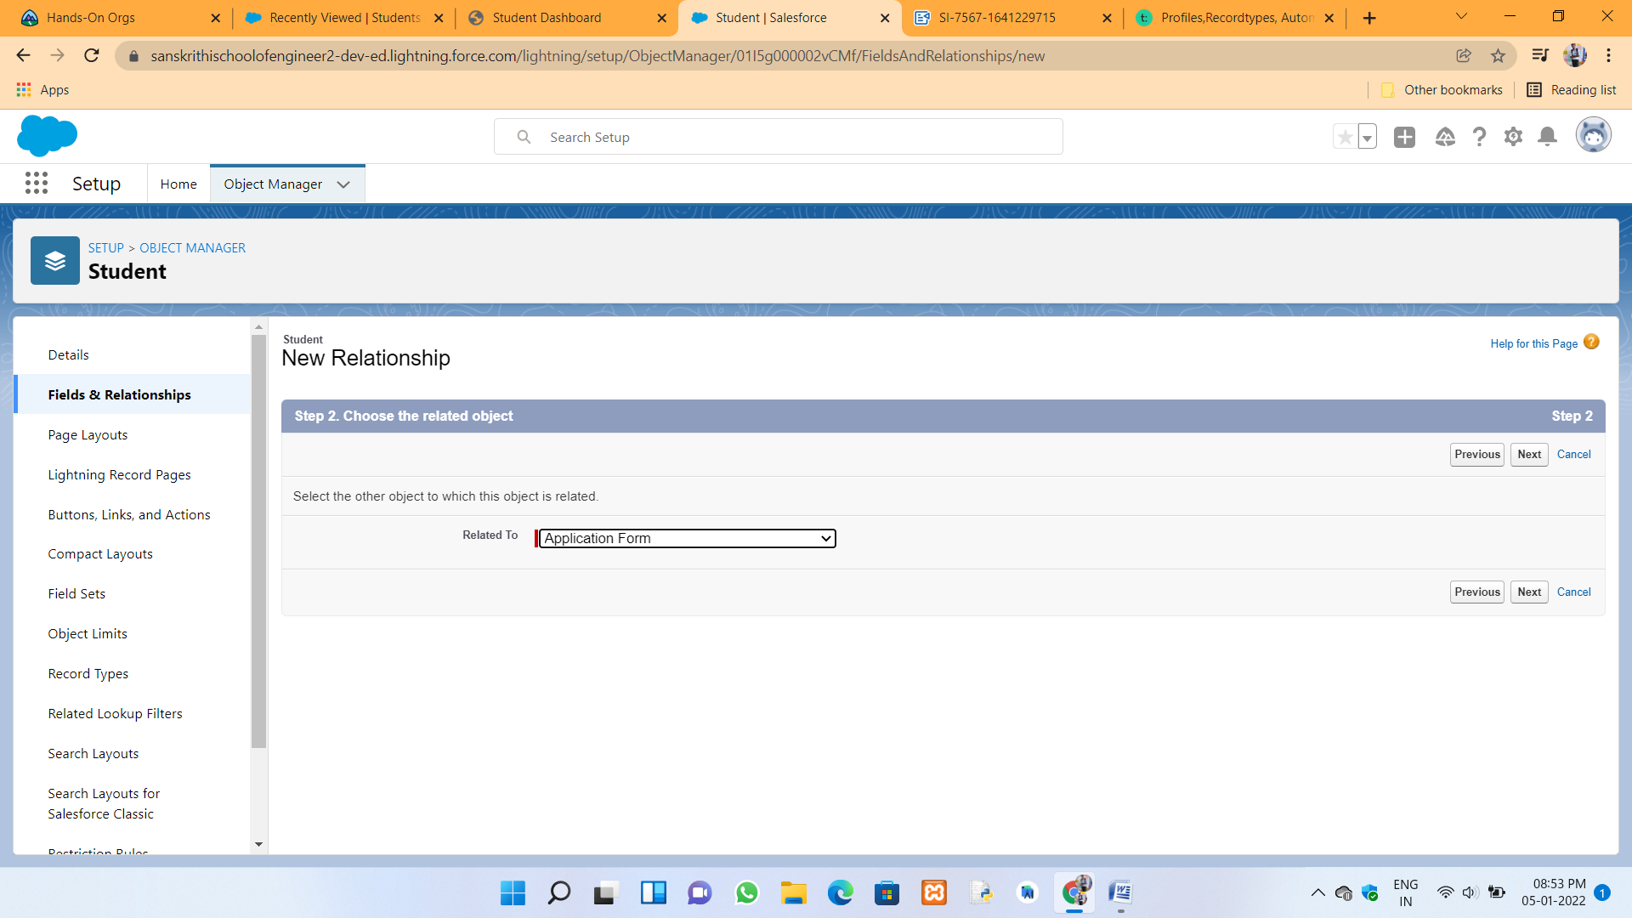

In this custom object to create College name field :



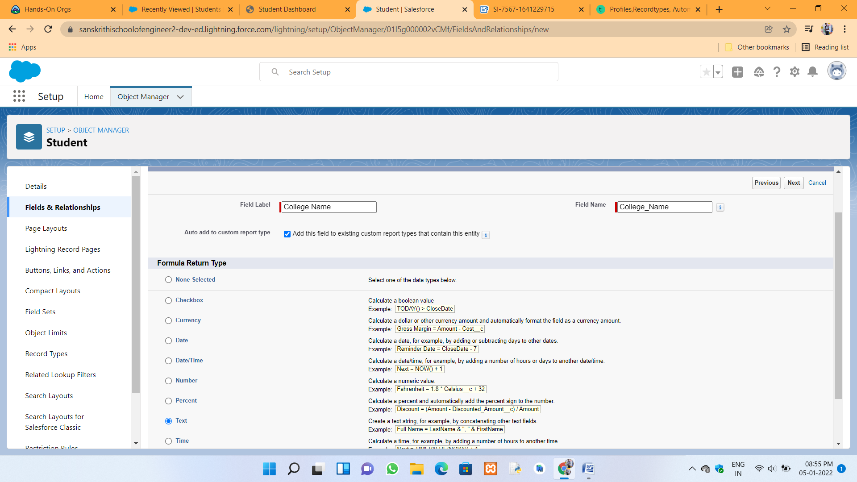

In this custom object to create Date of Birth field :





In this custom object to create Guirdian Name field :



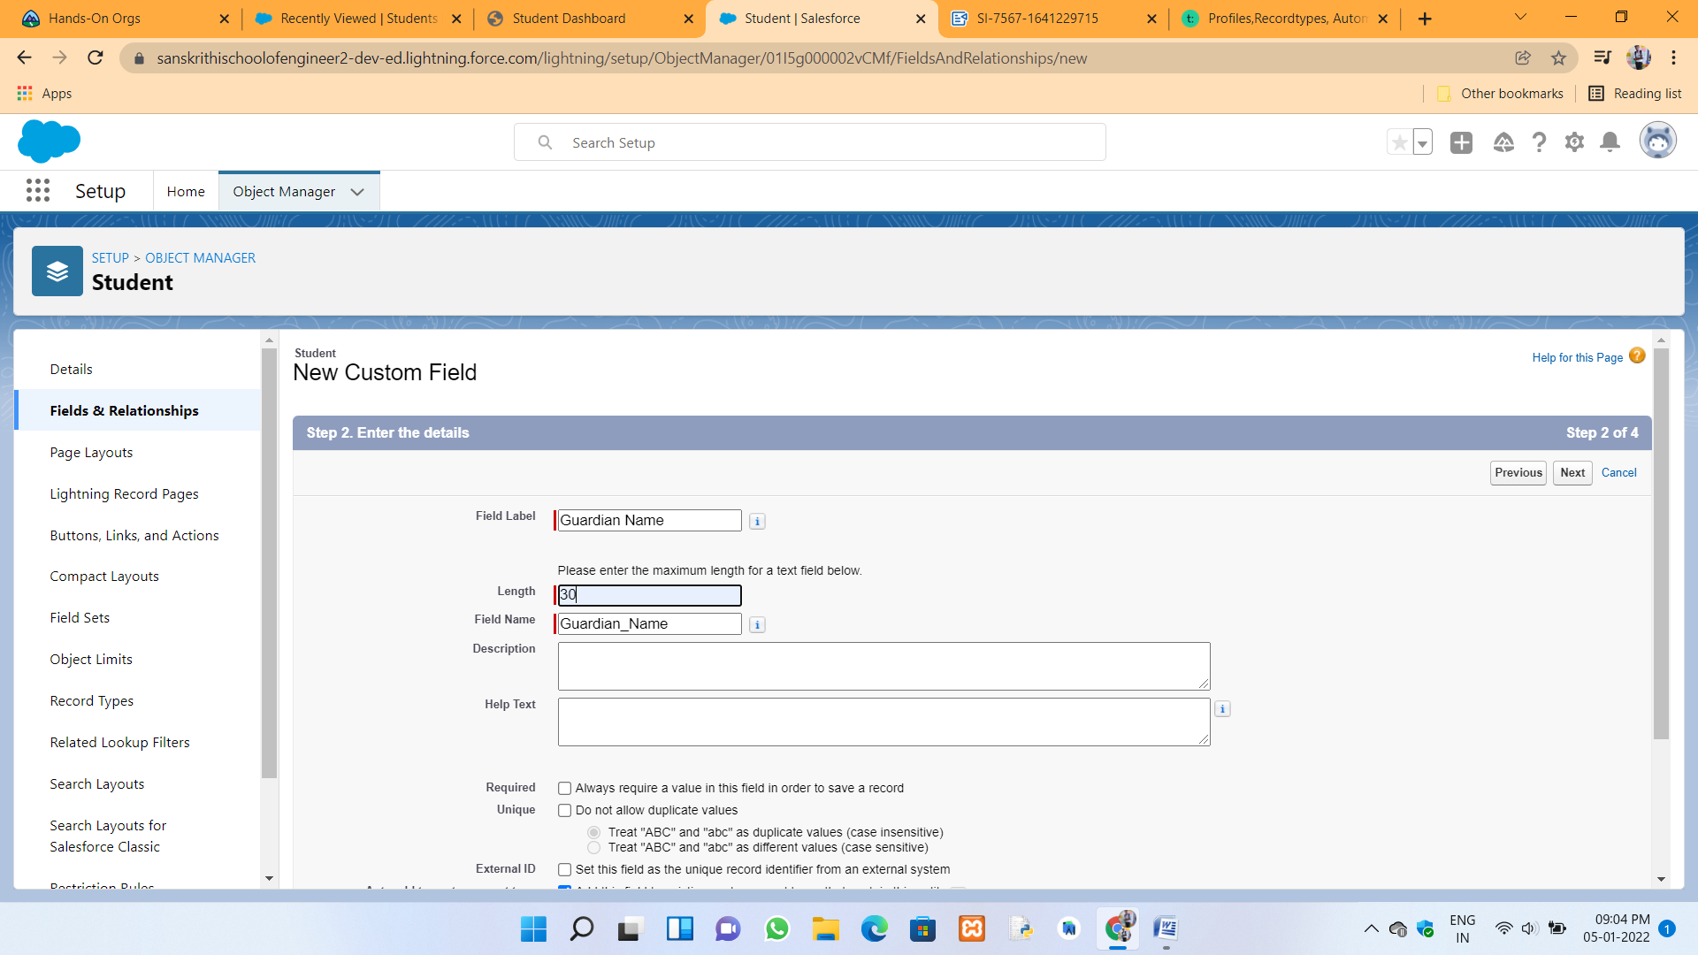

In this custom object to create Phone field :



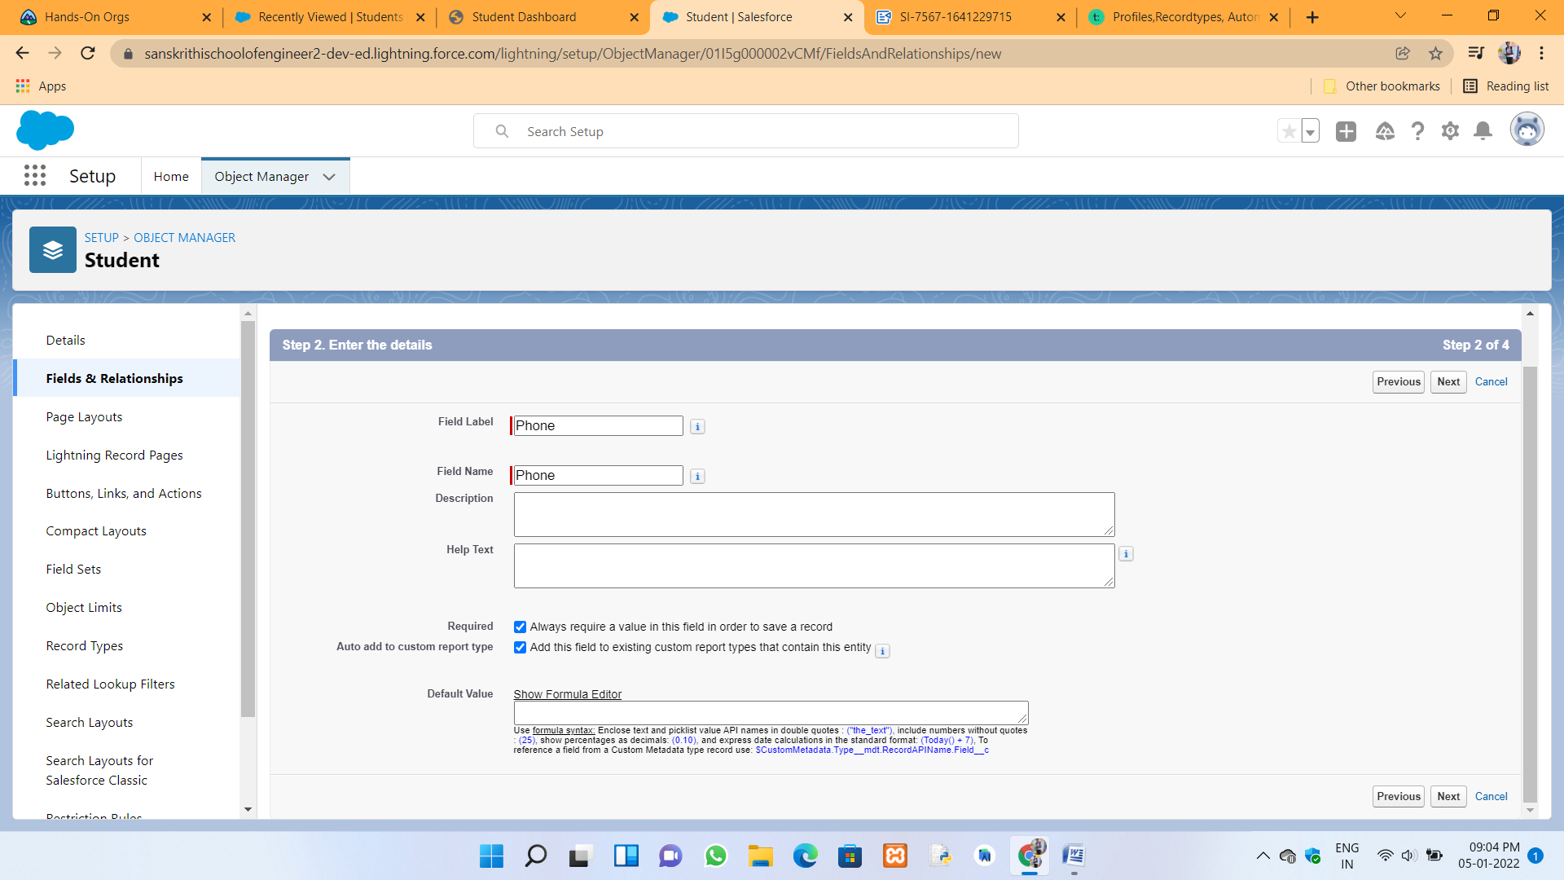

Subject object to create as a custom :



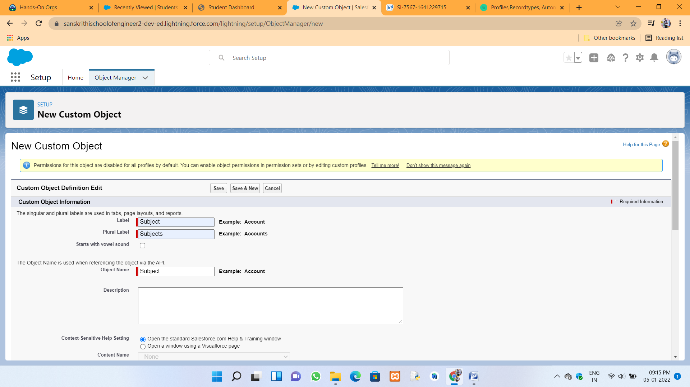

In this custom object to create Student ID field :



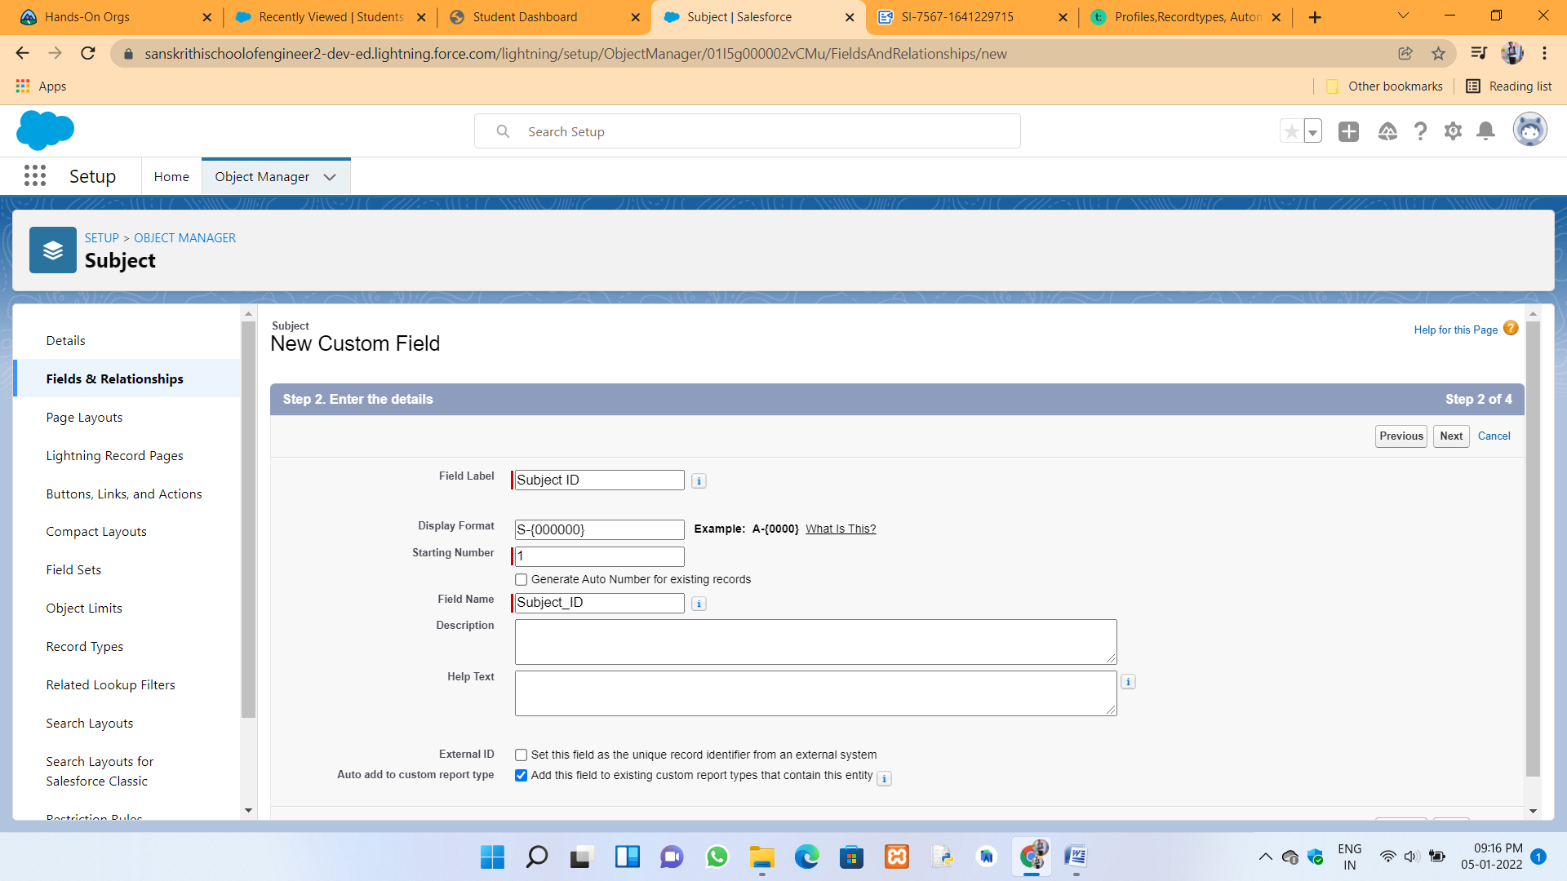

In this custom object to create Paper1 field :



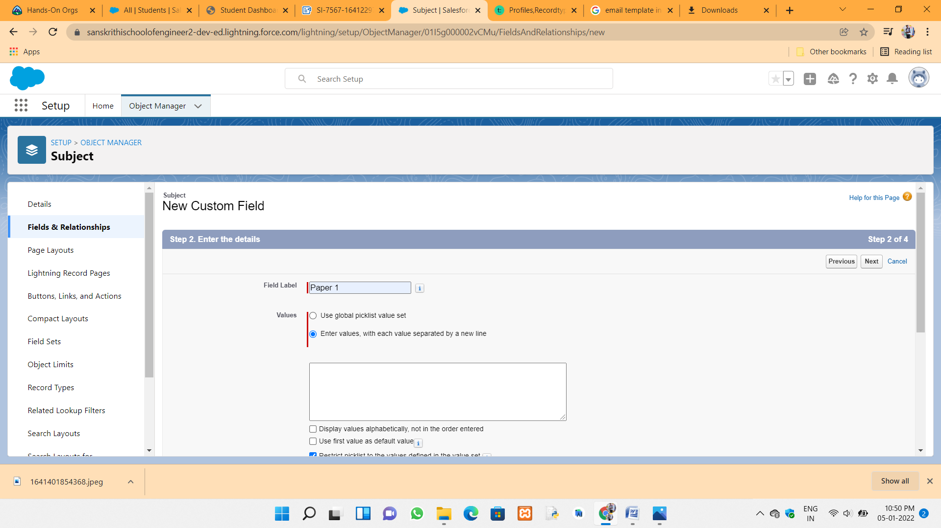

In this custom object to create Paper 2 field :



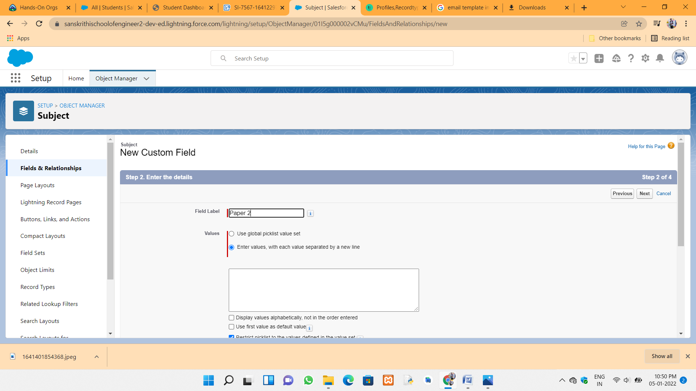

In this custom object to create Student field :



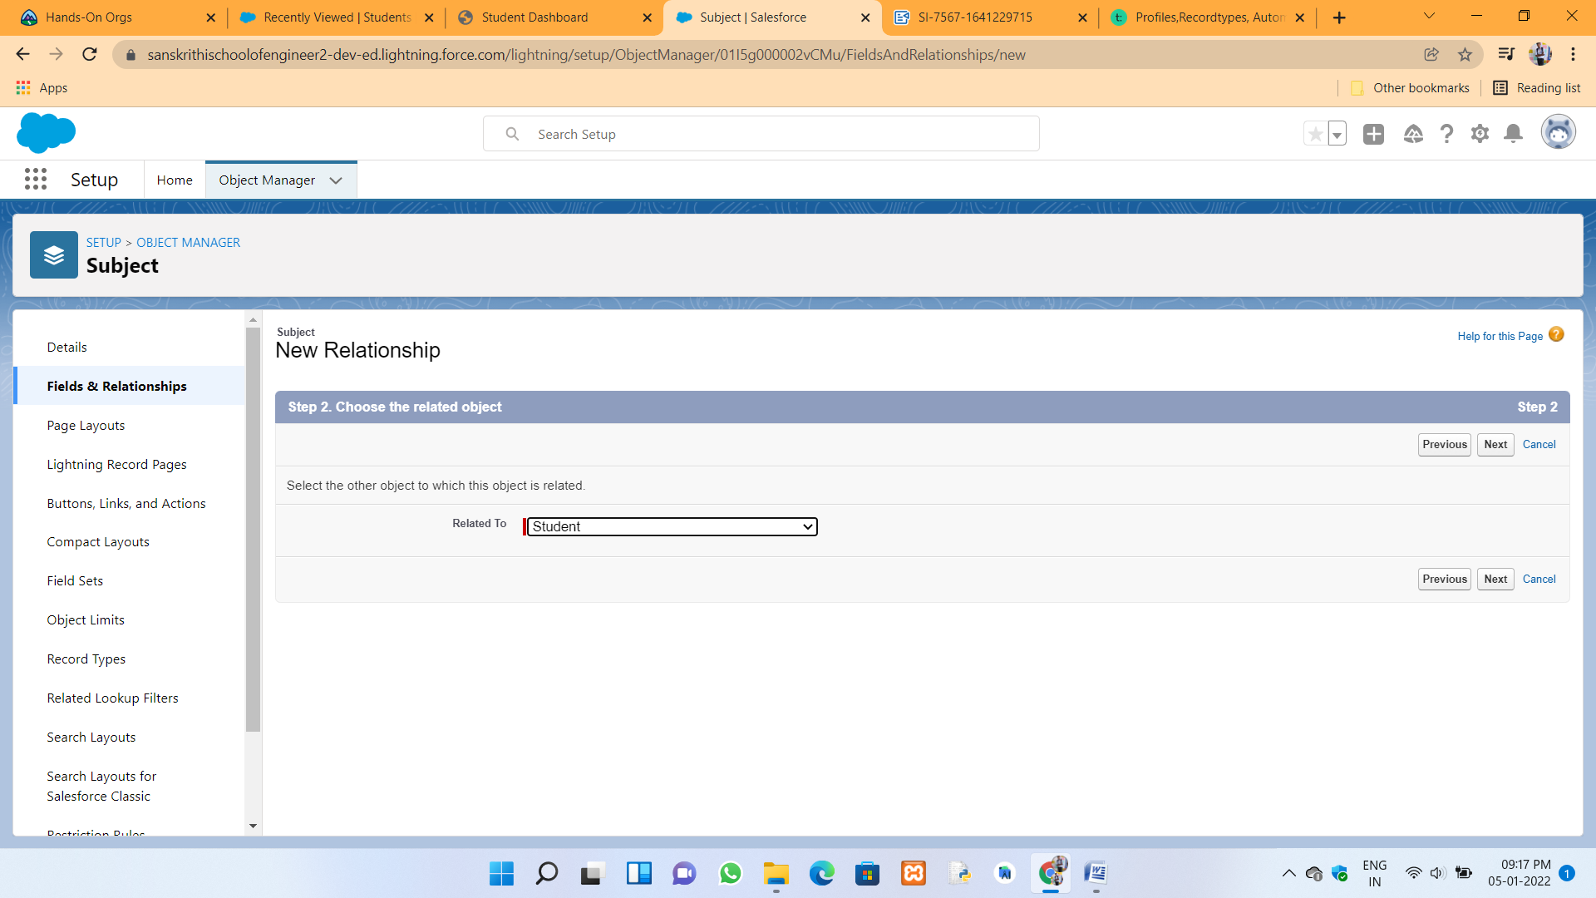

Student object under fields :



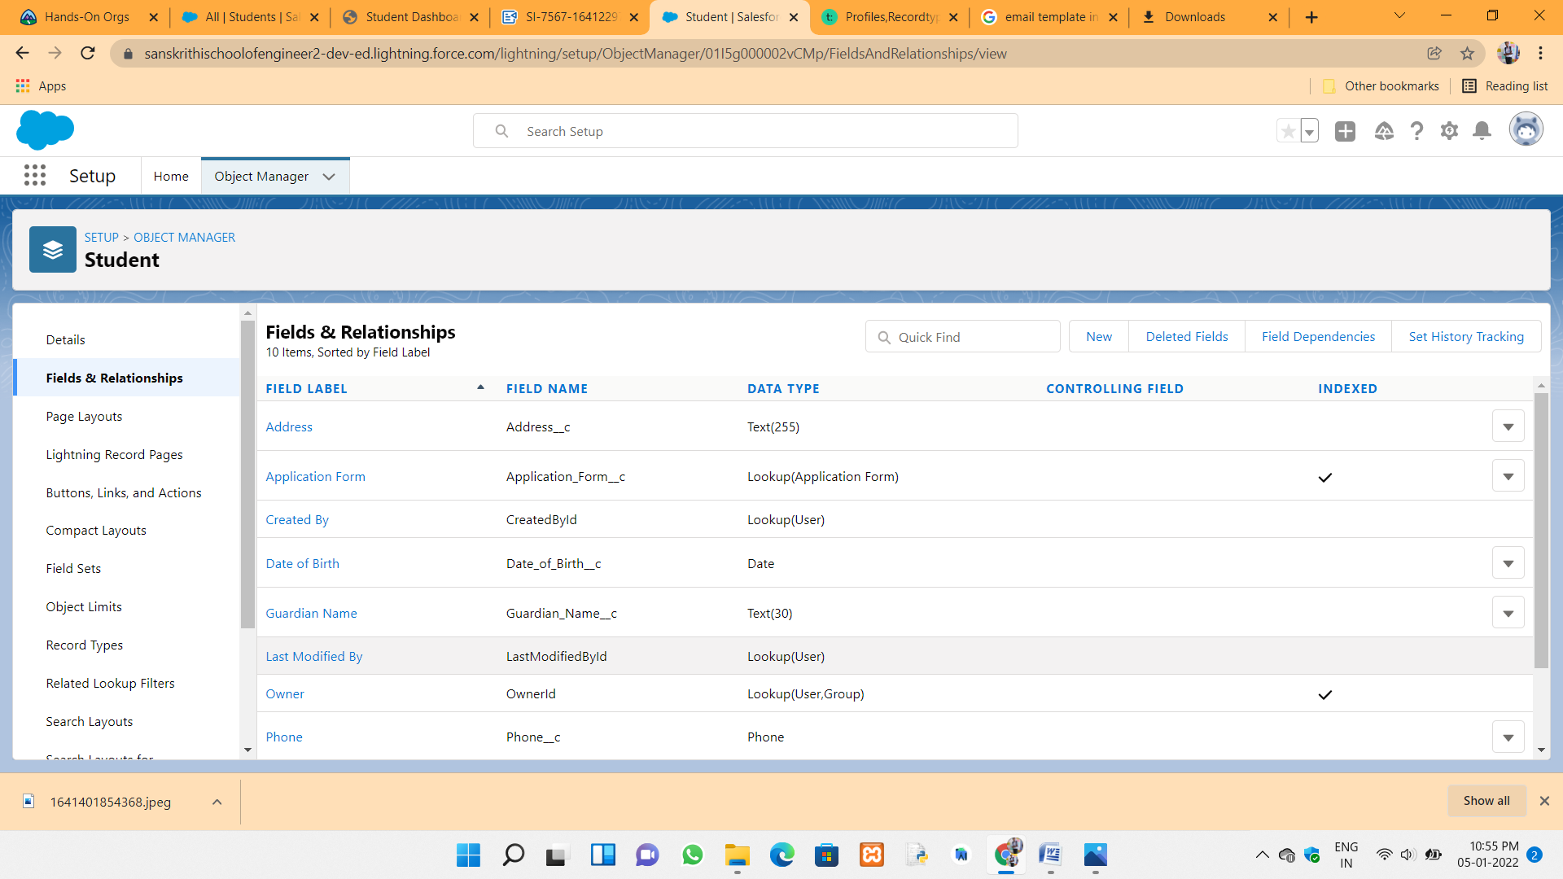

Subject object under fields :



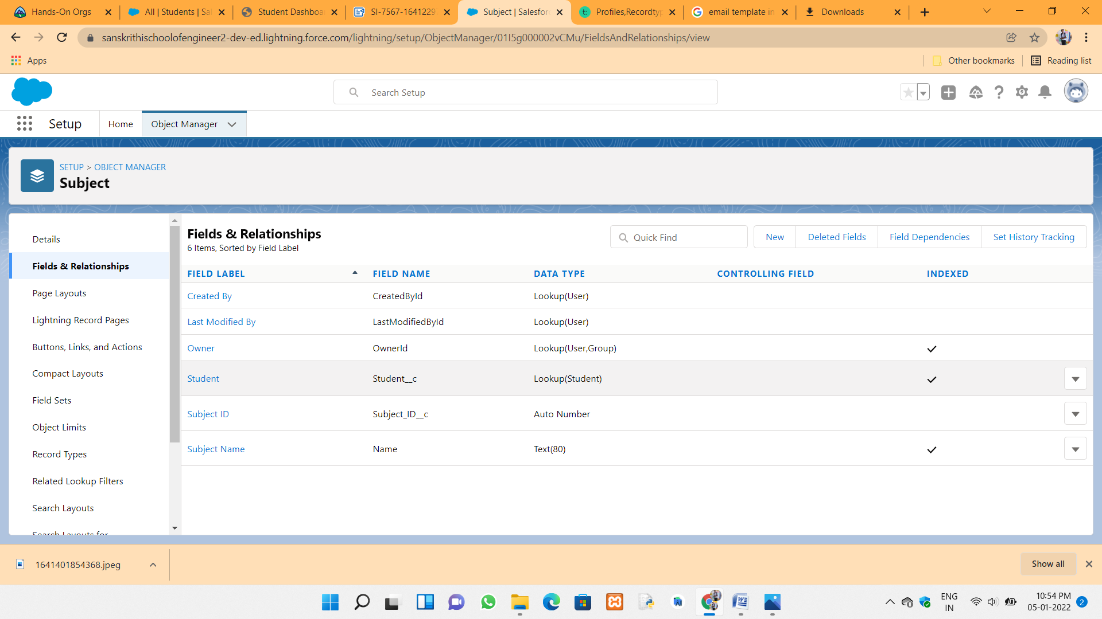

Select relations through Schema builder :



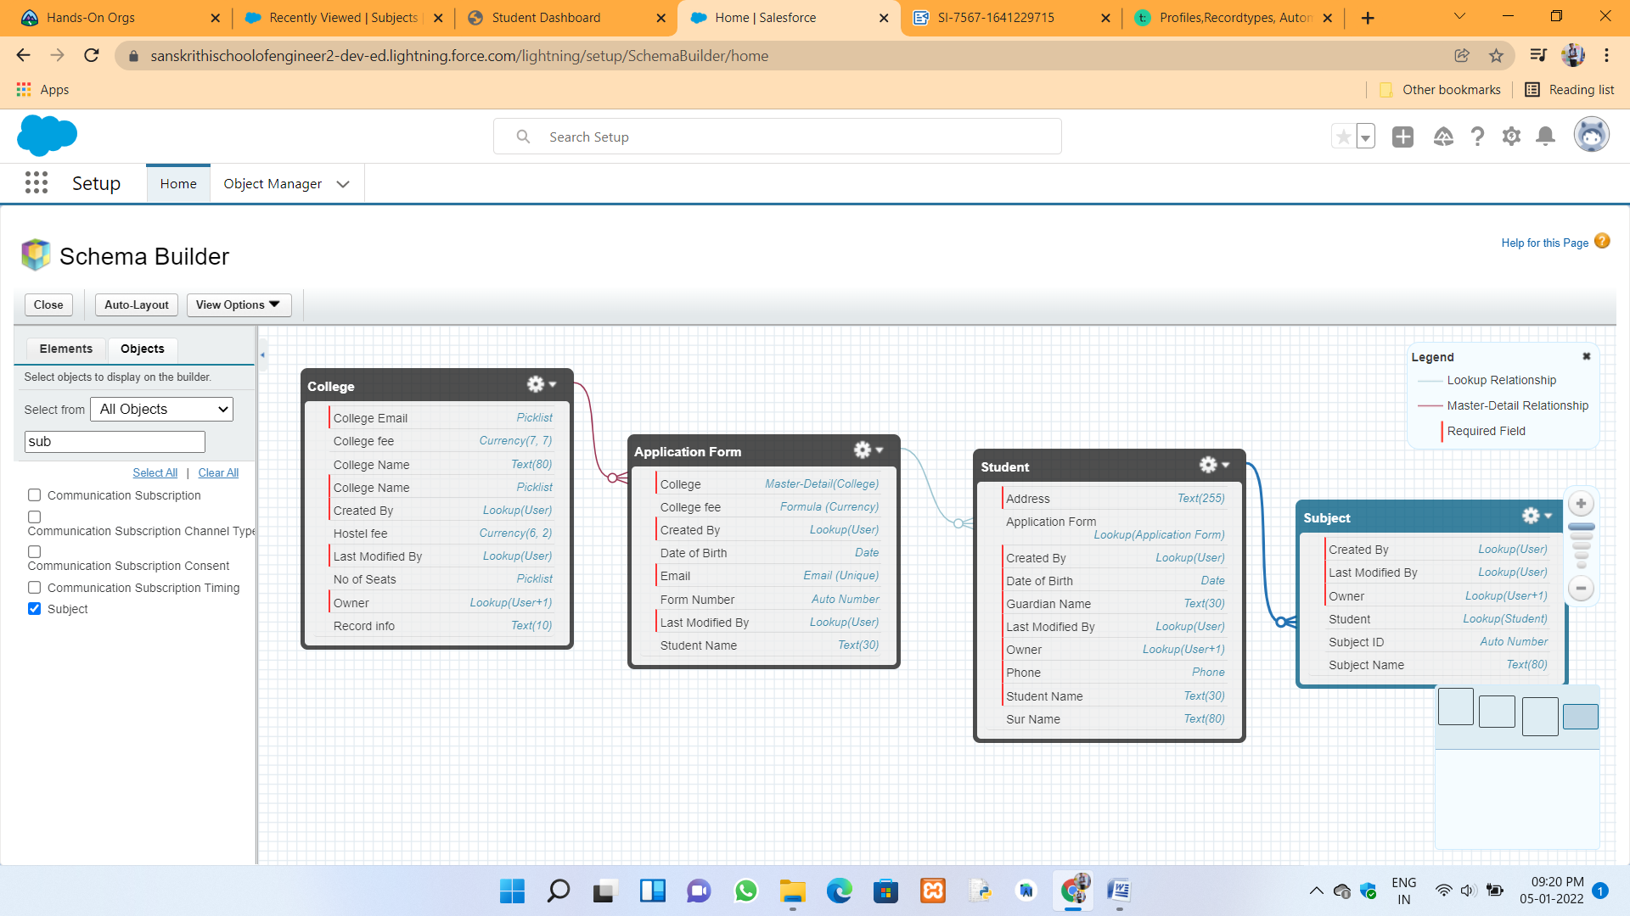

Giving Accessing to the System administrator :



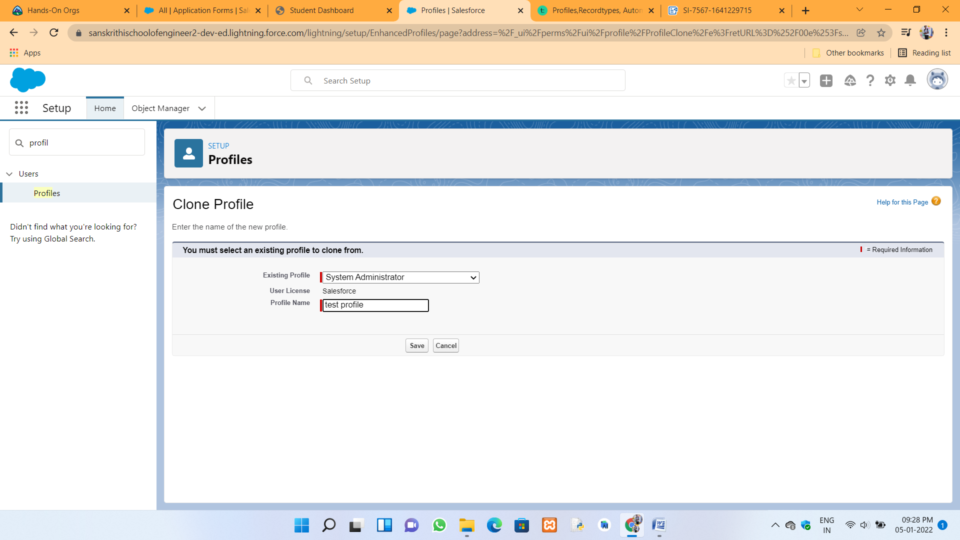

In the account object below record types and reflect into the college management application :



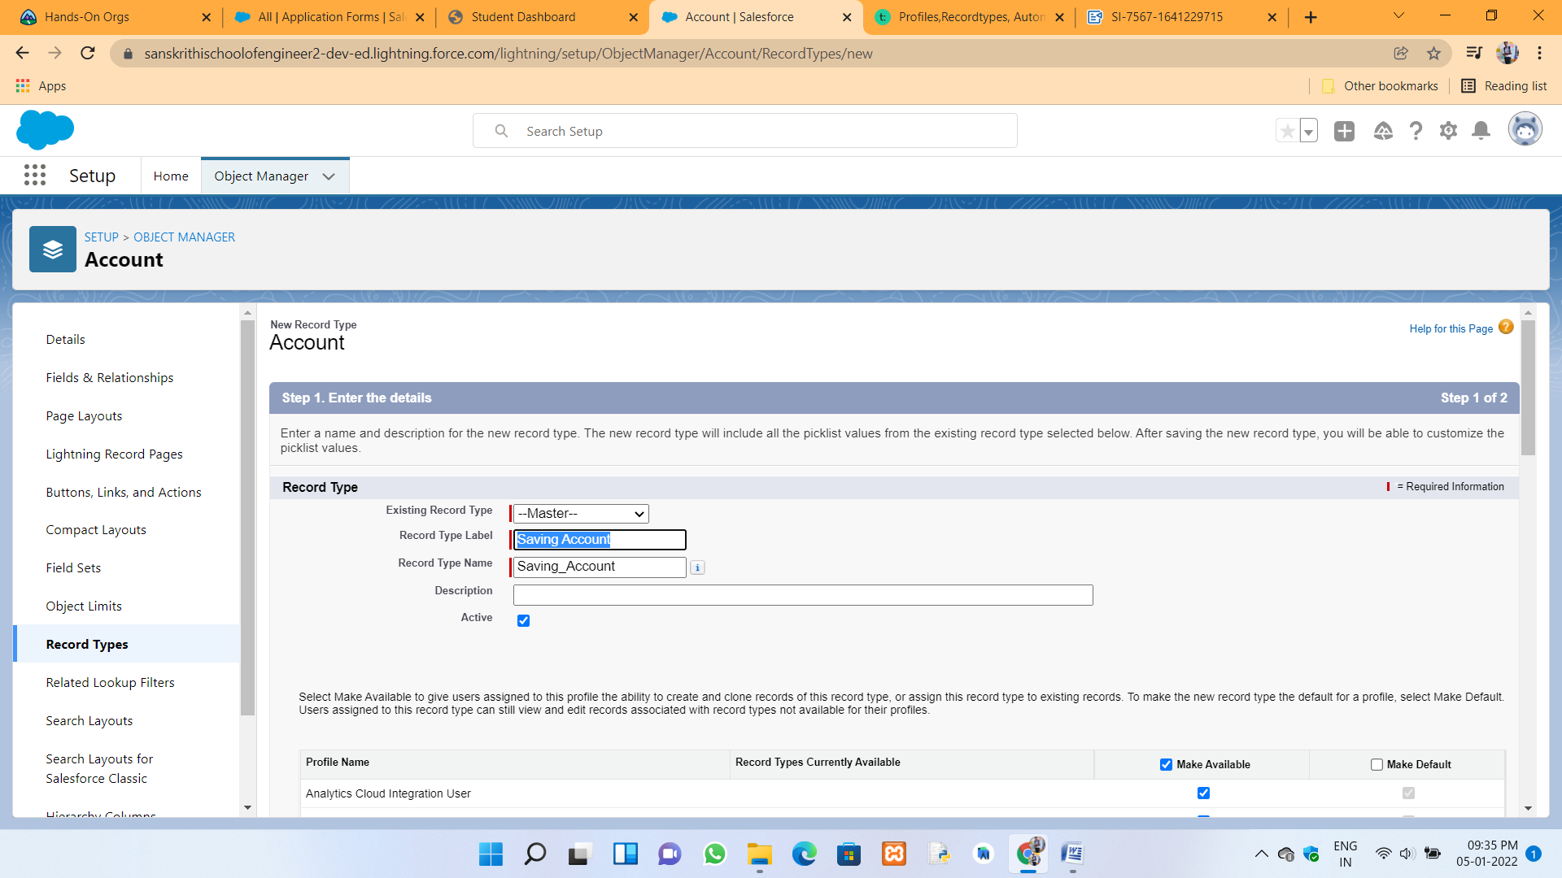

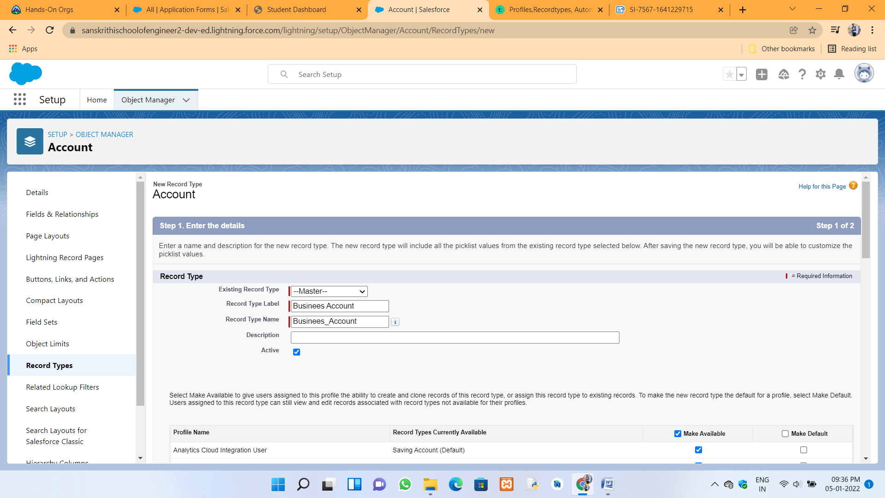

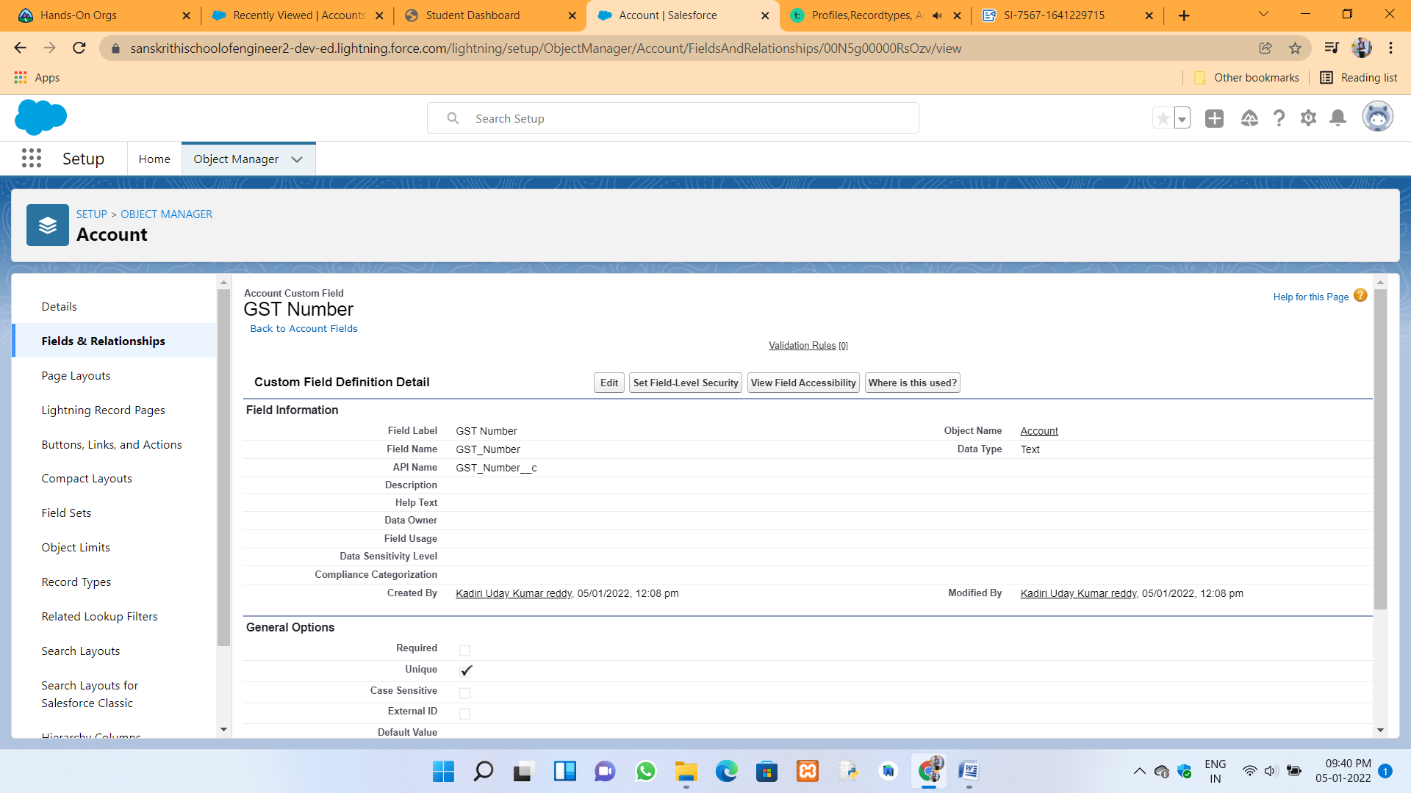



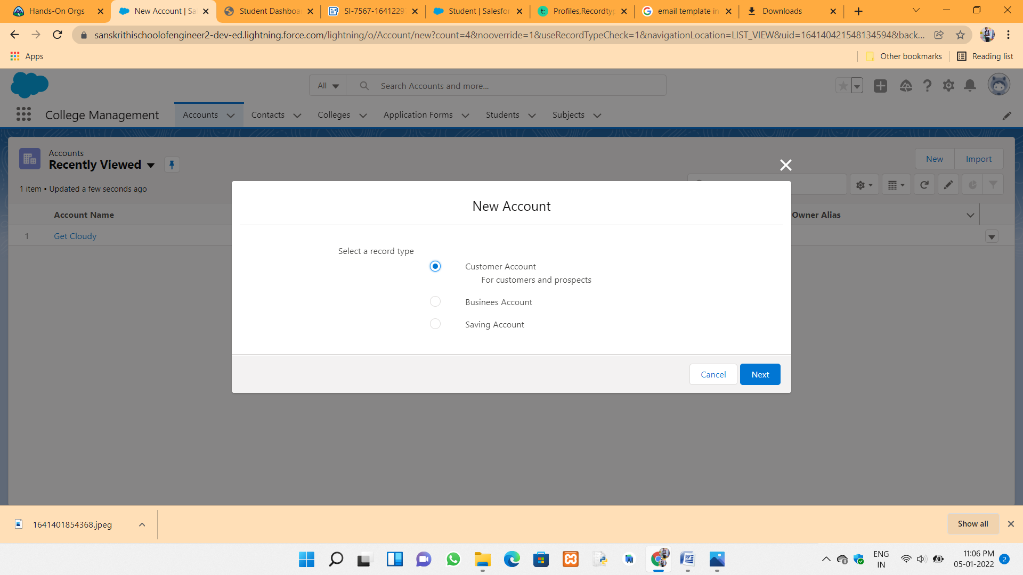

Using Process Builder to Create application form process master :



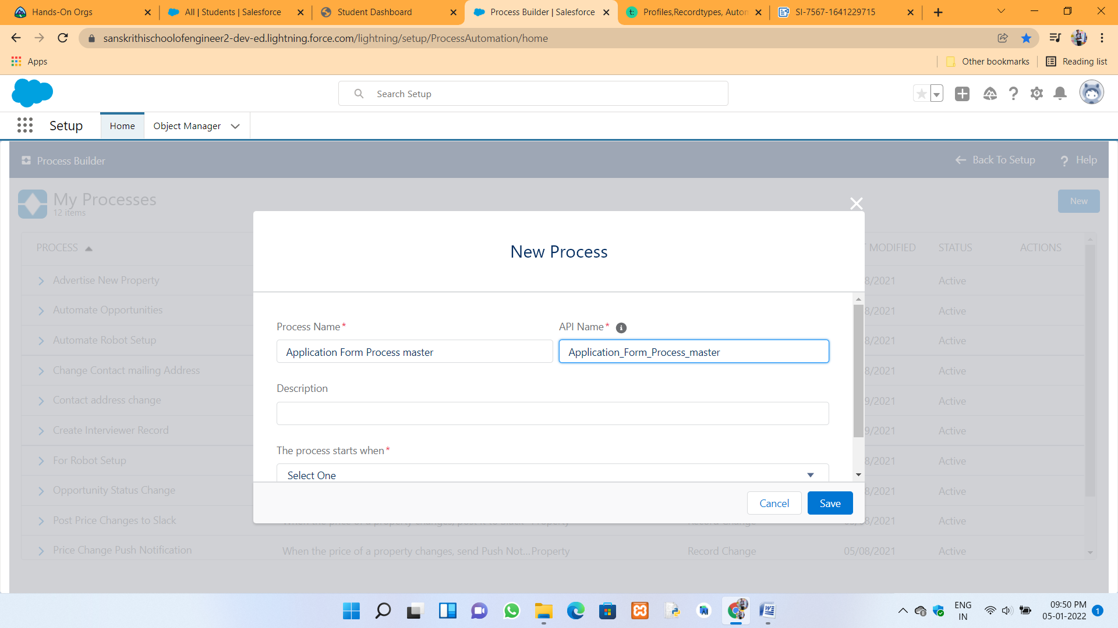

To create the process in Process Builder :



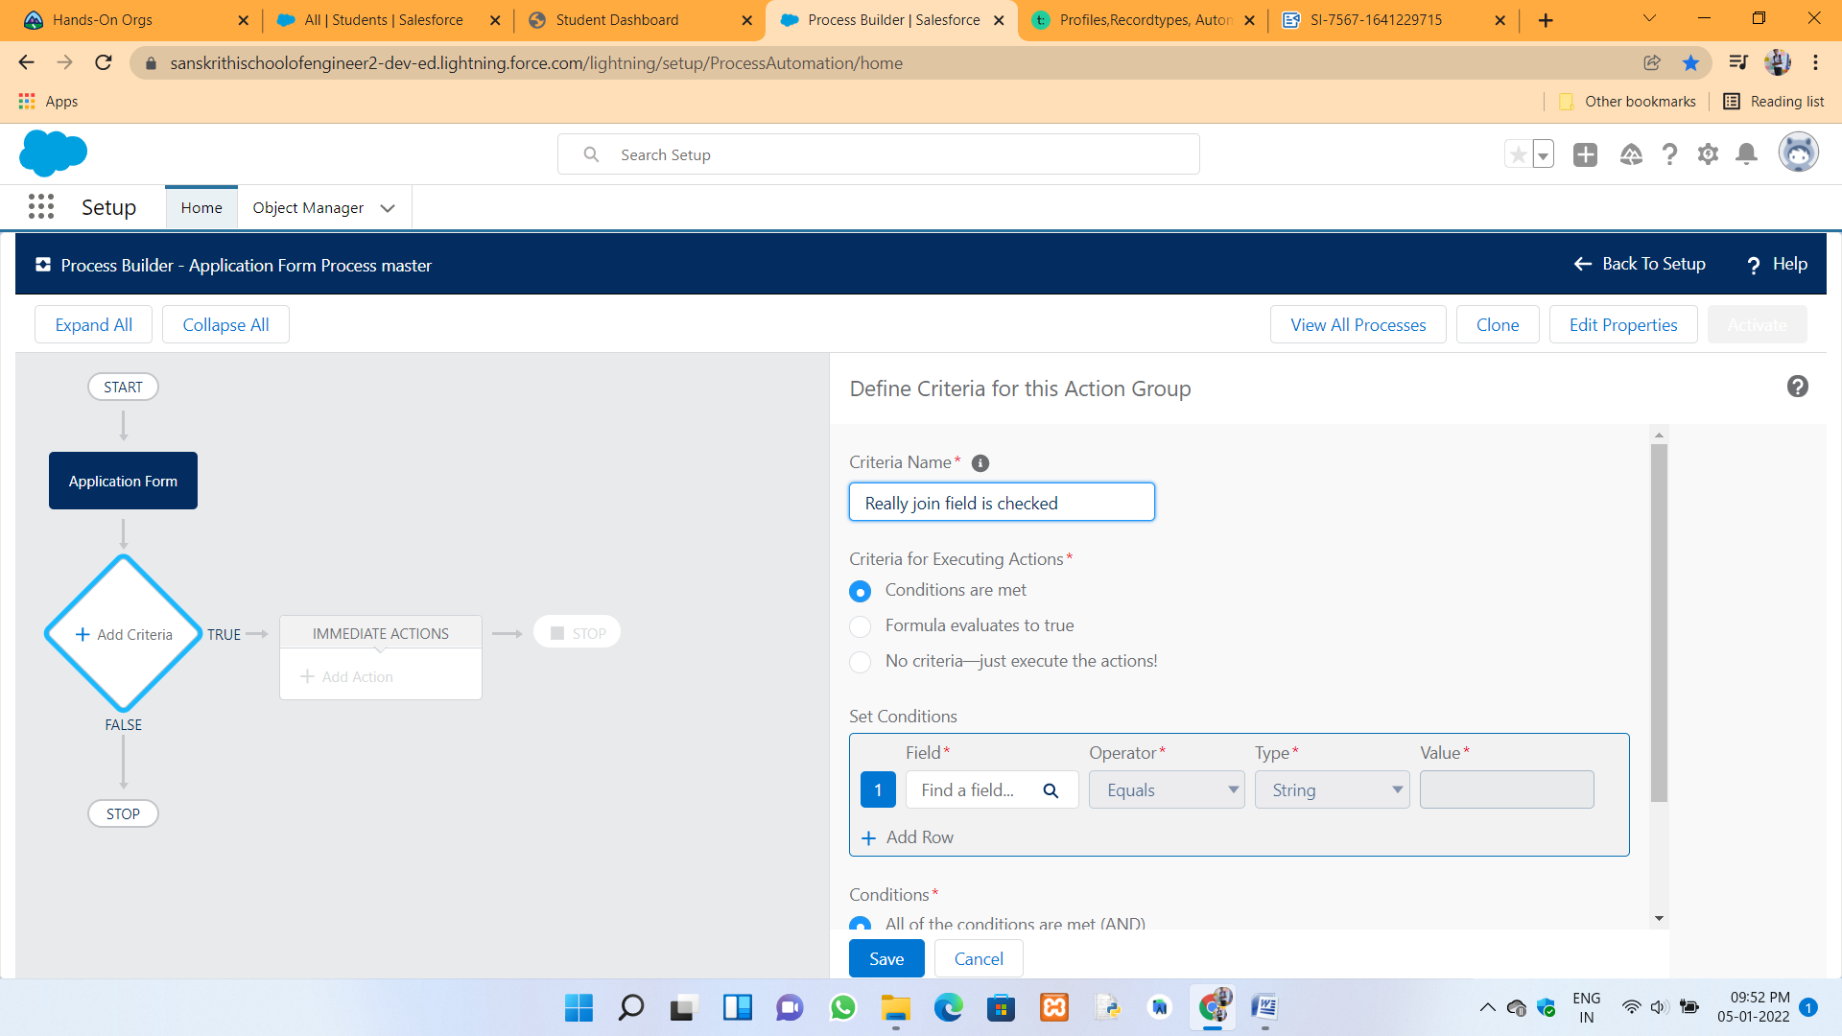

Email templates creation :



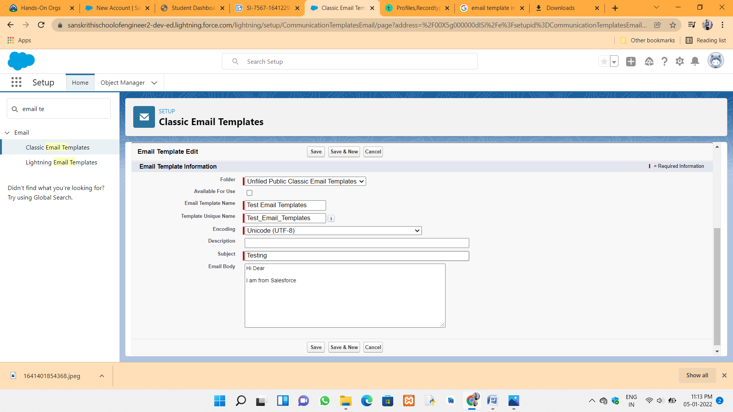



**Day 4 :**

**Topic :** Process automation for Appplication form in the college management application Workflow and flow builder

**Milestones / Activities :** Workflow, Flowbuilder, Security model, overview of apex

**Description :**

**Workflow :** Workflow in Salesforce is basically a container or business logic engine which automates certain actions based on particular criteria. If the criteria are met, the actions get executed. When they are not met, records will get saved but no action will get executed. ... Workflow Rules.

The certain points to create

1. record type 2. email creation 3. task creation 4. outbound messages

**Flow builder :**  In Salesforce, a flow is an application that automates complex business processes. Simply put, it collects data and then does something with that data. Flow Builder is the declarative interface used to build individual flows. Flow Builder can be used to build code-like logic without using a programming language.

some of the explanation about the flow builder working :



In this flow builder have a 5 different flows. You have to use scrren flow and record

triggered flows.

In this one two separate flows are there, This are free form and auto compete form. You have to work on both flows.

flow builder (Lightning Flow)

the different settings is get records and update records etc.

for (i=100) {

collection variables set, map, list

select id, Name from student where lame not empty limit 1,

for( i = 100 )

form clase date current day 30:

when readyto join as true (application form object), then only create a student record.

Stringm, id, date, list, set

in term of record trigger flows,

we have a variable called $Record. application form cord 40 SRecord prior holds old data of application form

**some important things you will see :**

1. flow builder outbound message
2. Security model in salesforce :

* object level security
* field level security
* record level security



a record that you arr creating has to be private. only you will be able to record.

profile - test profile

college --> Application form both are in MD

you want the record to be private

Sharing Rule opens up when DWD is private or public read only

Overview of apex and some settings and datypes discussed in this developer console :

It is programming language. it is similar to java and its devoloped in the vs editior and lwc editor

**Screenshots of milestones / Activities :**

Process automation for application form and it create the process name is Application form process master :





Create The Student Record Using Flow :



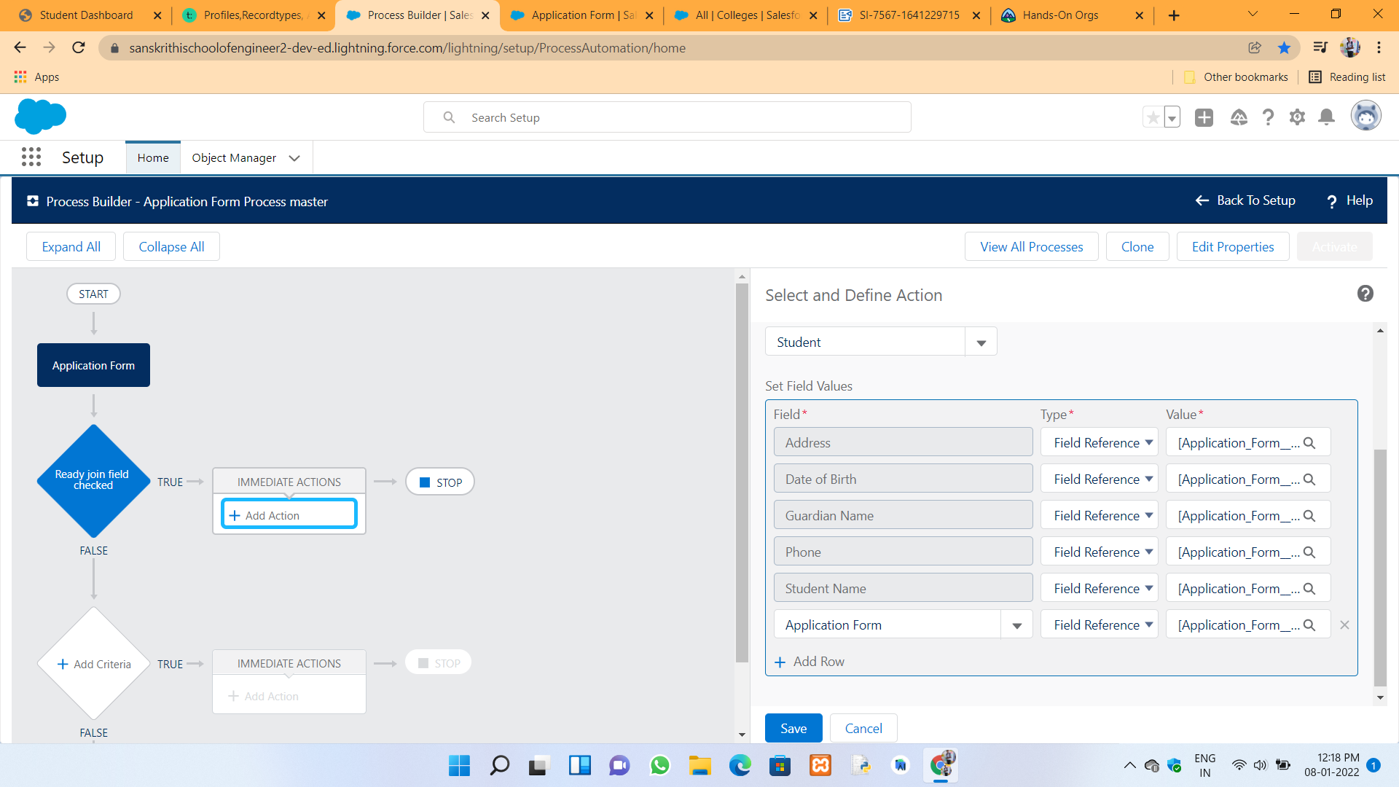

The action of the ready to join in the student object :



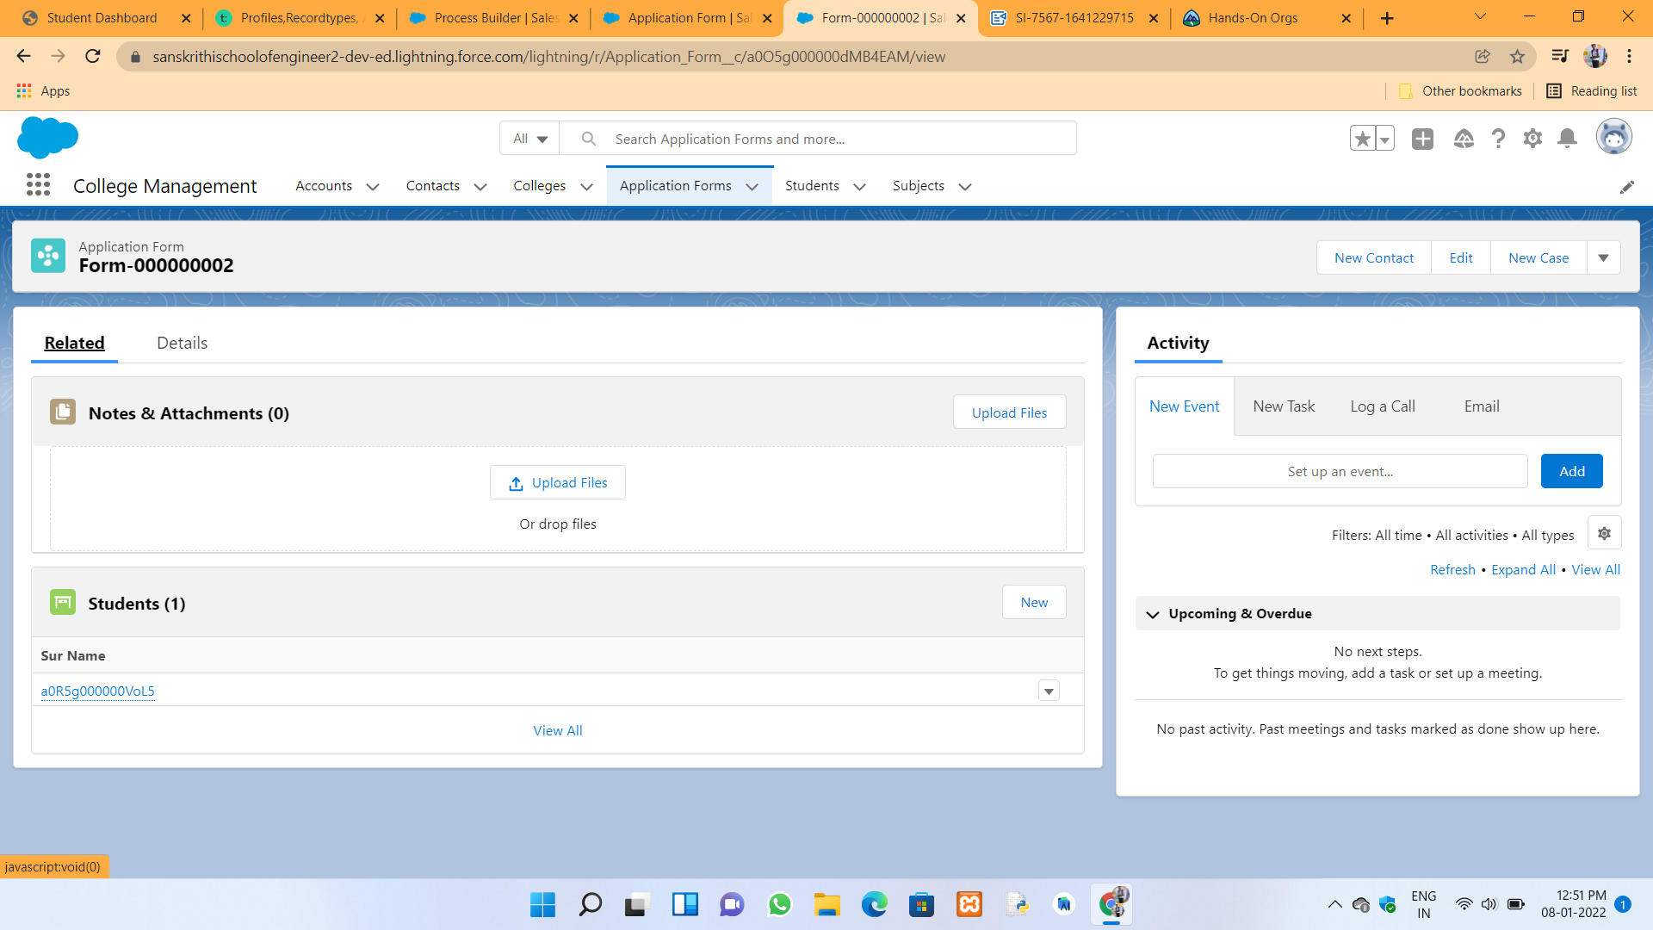

FLow builder Creating and actions in to be explained :



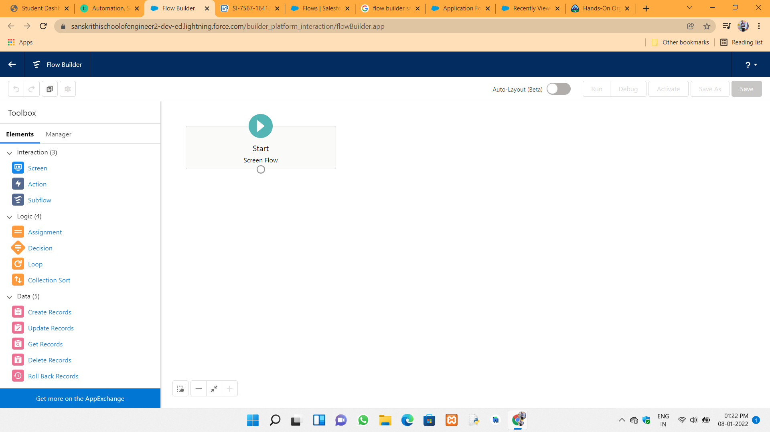

Get Records and loop and new assignment and update records :

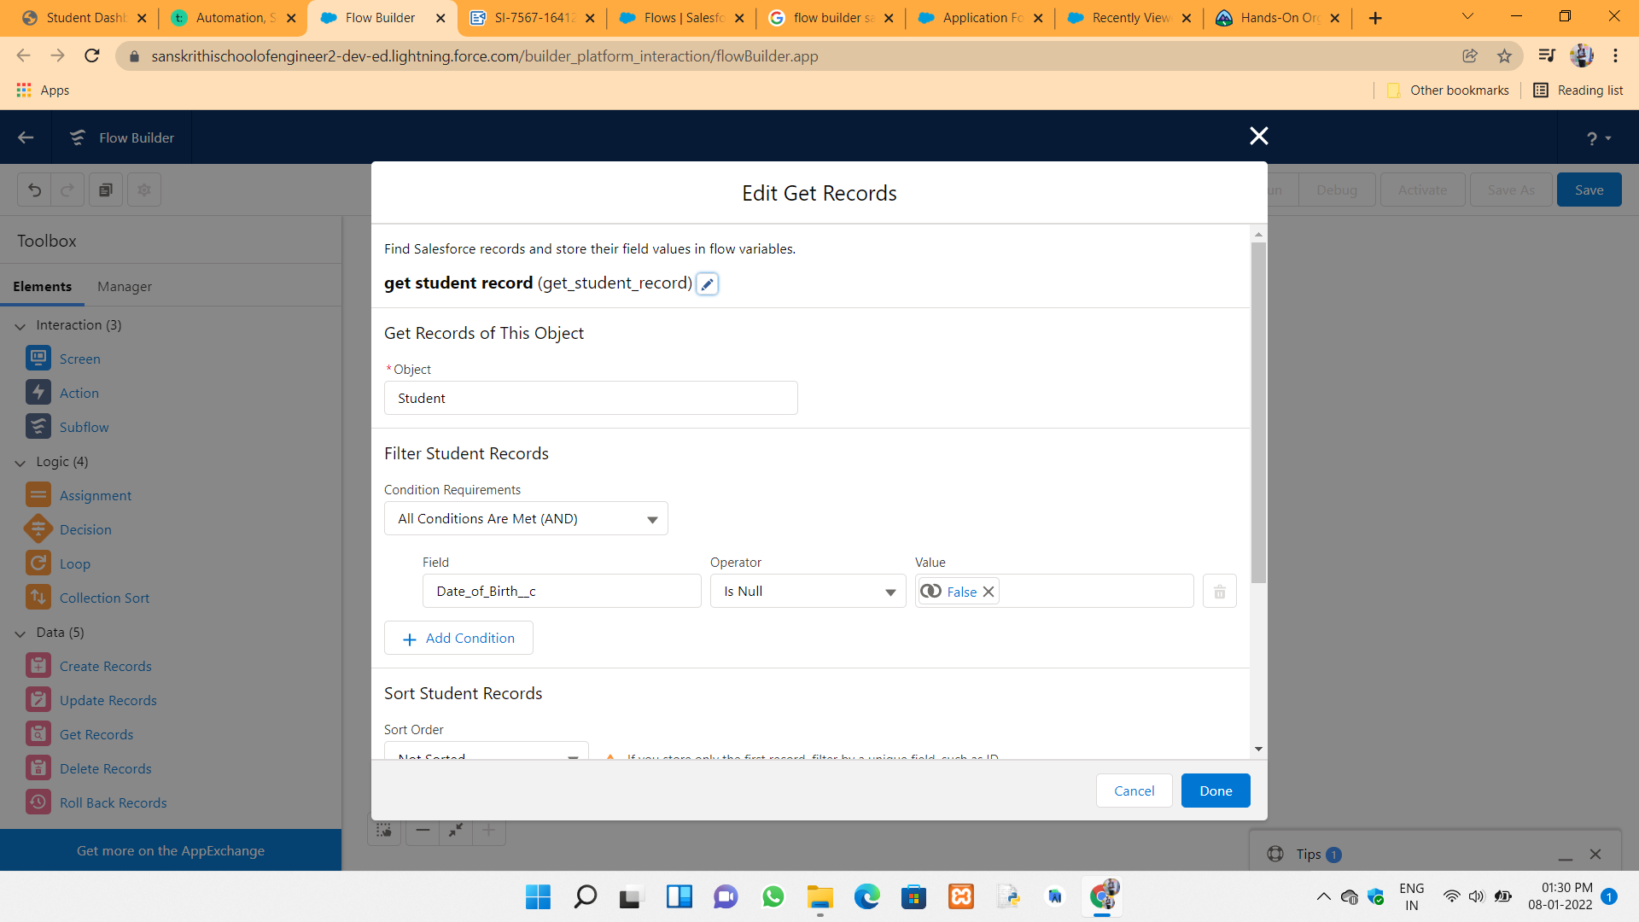

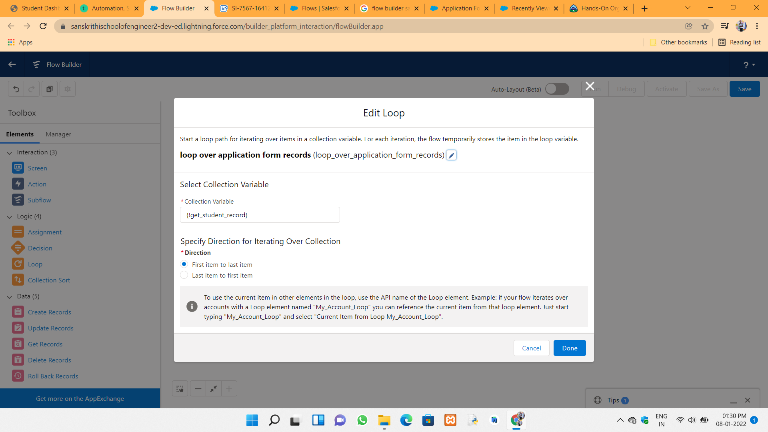

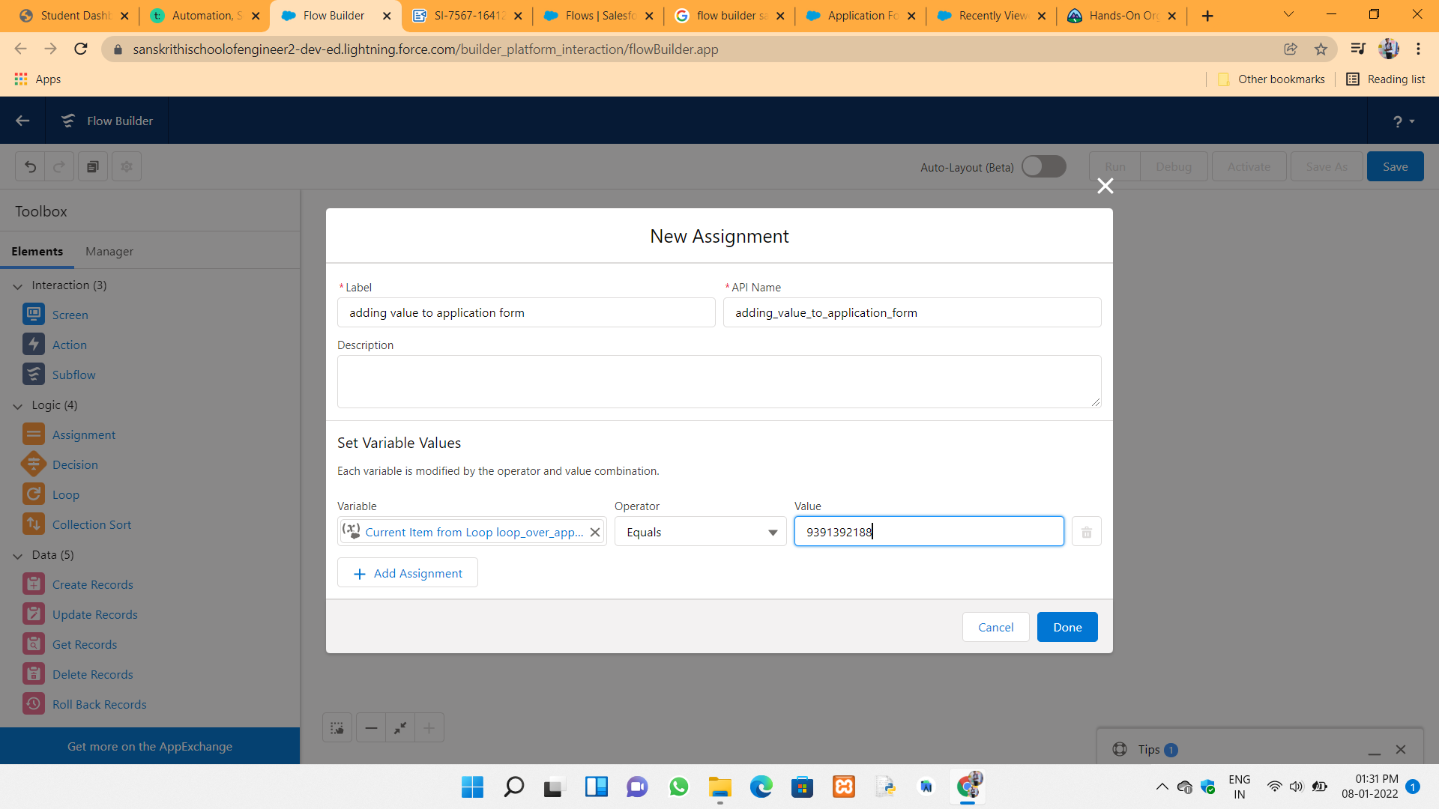

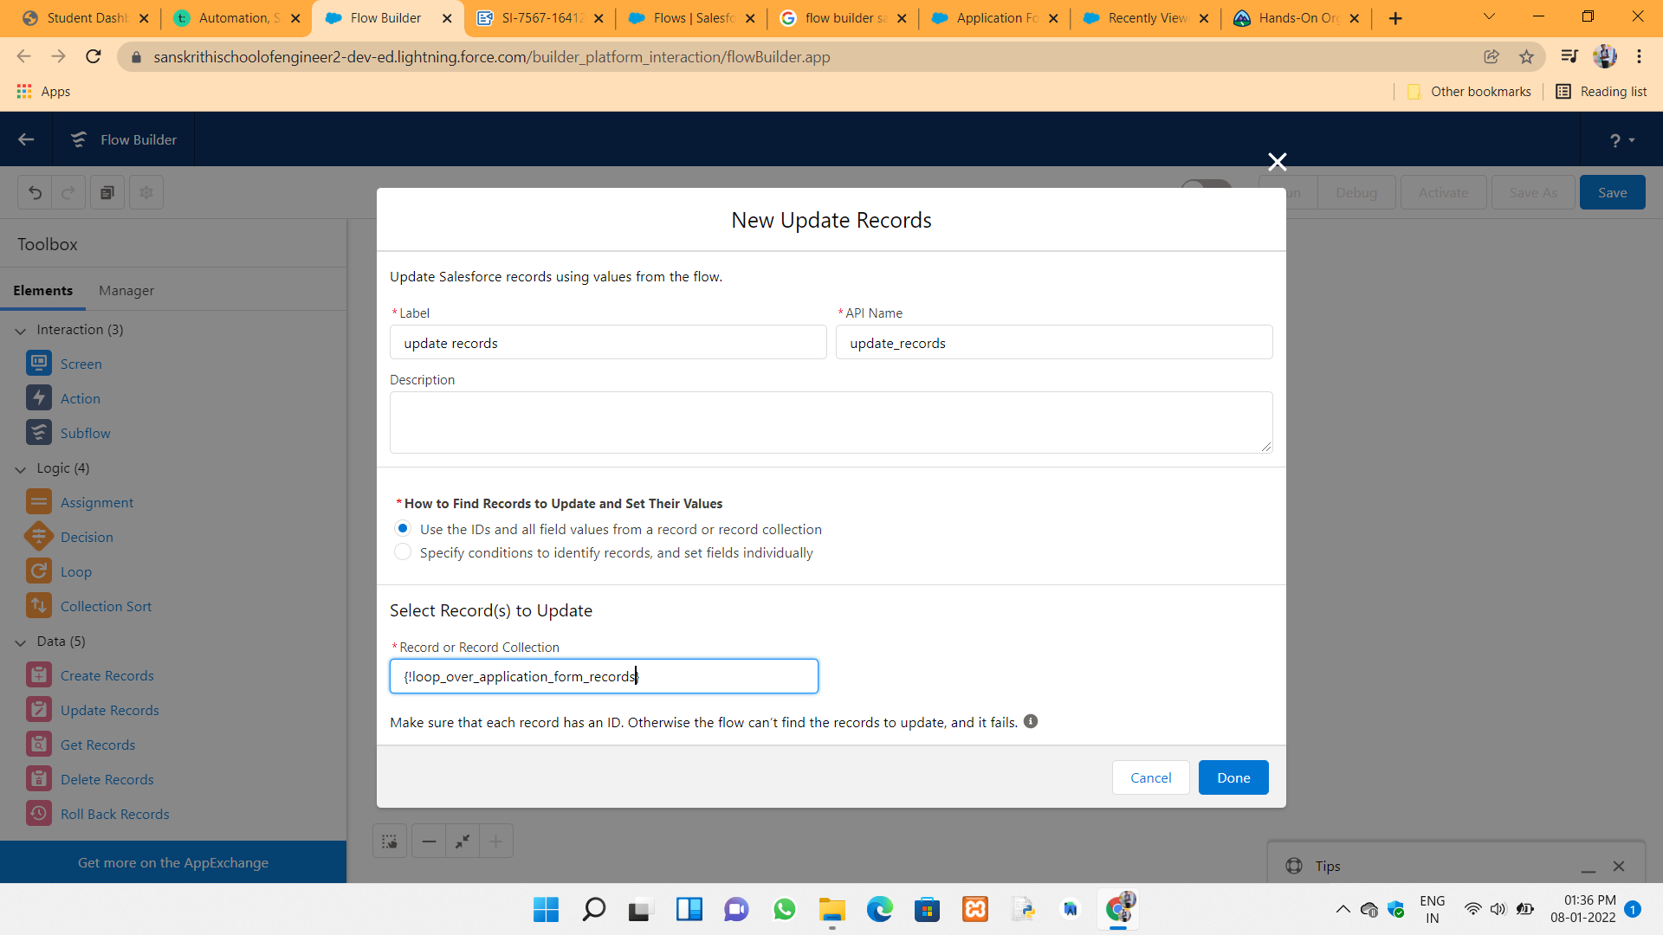

The total flow is below shown all :



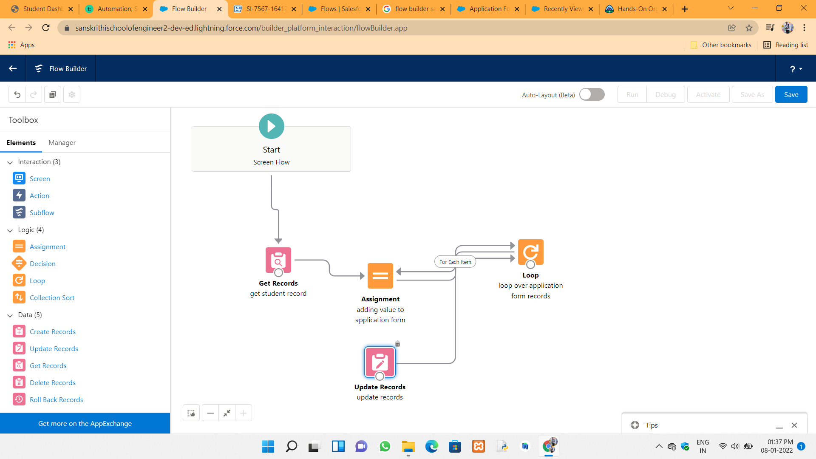

Record triggered flow selection and some process in that :

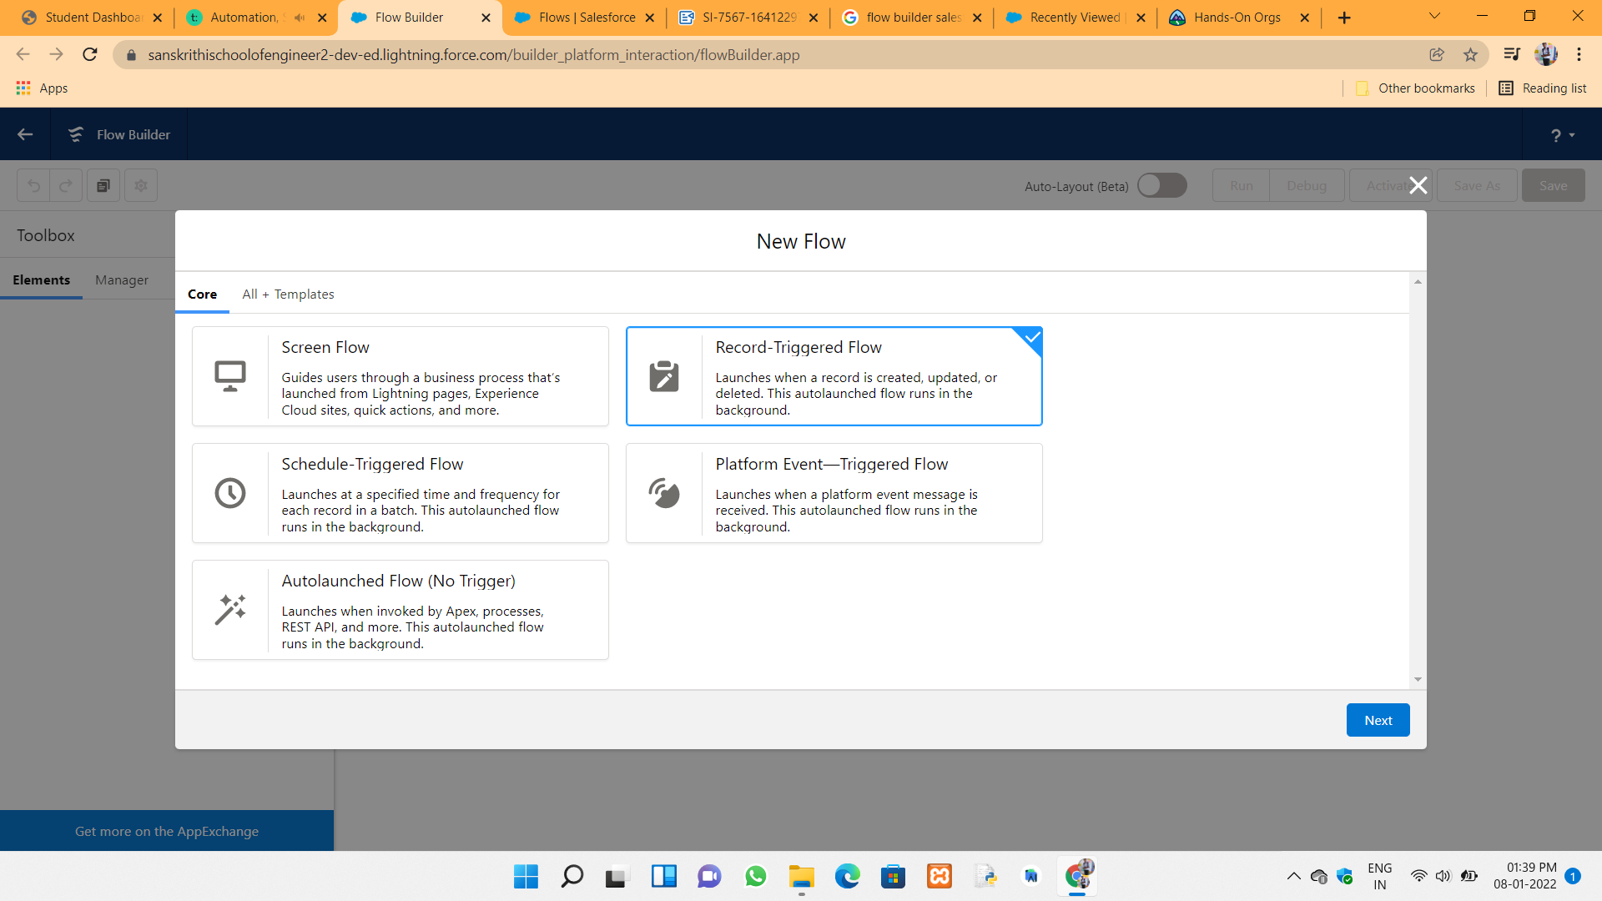

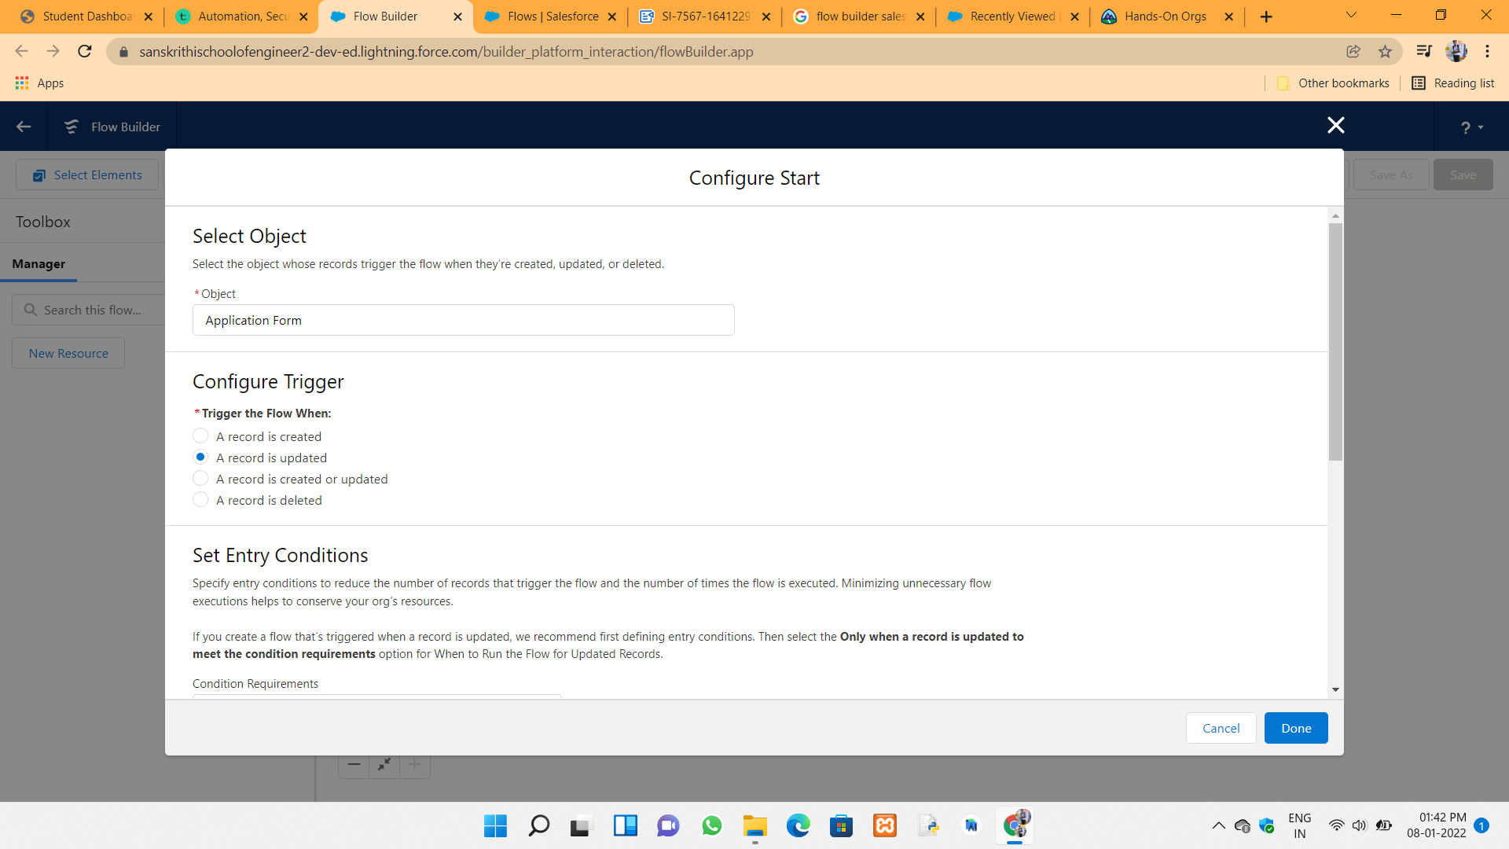

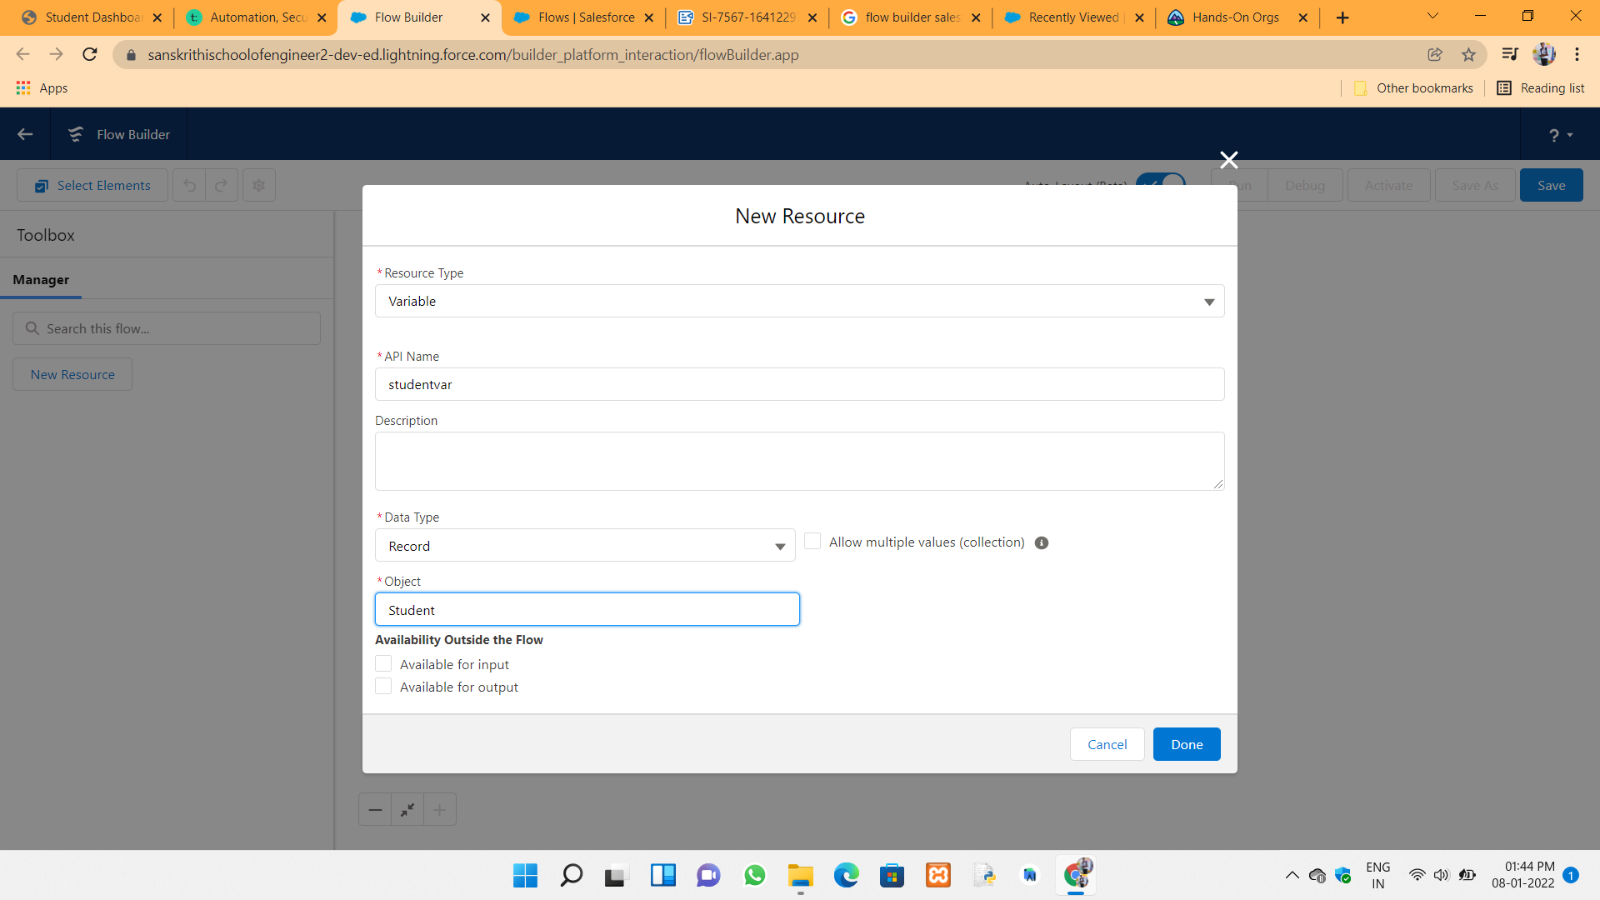

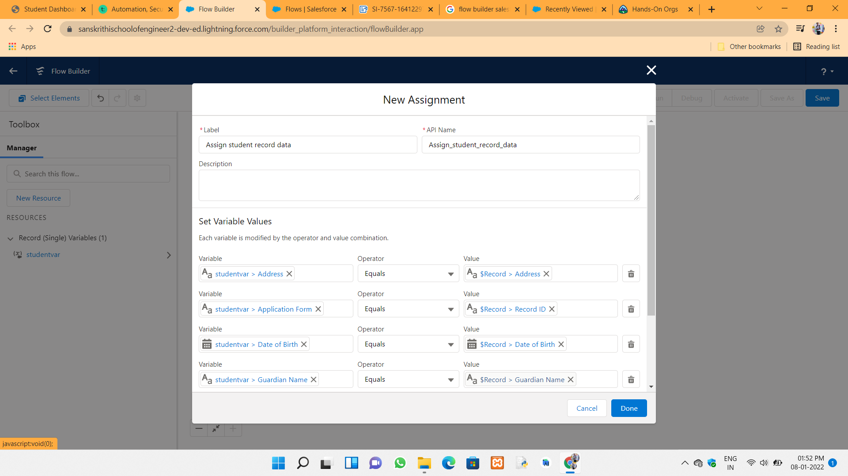

The overview of Record triggered flow is :



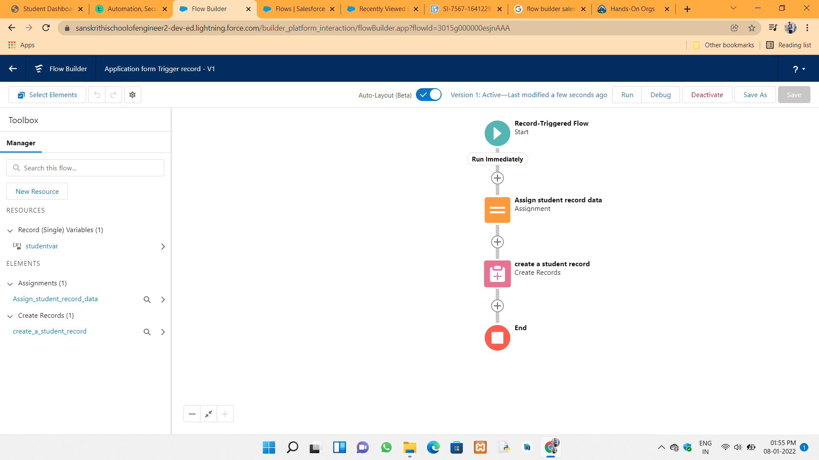

Overview of apex and some settings and datypes discussed in this developer console :



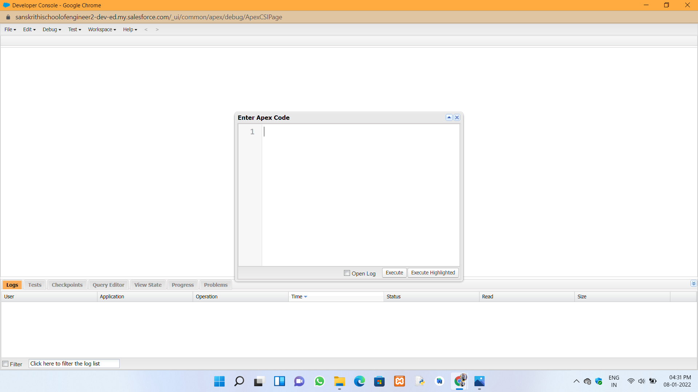



**Day 5 :**

**Topic :** Apex programming concepts

of

**Milestones / Activities :** Apex class and synchronous and asynchronous apex and soql

**Description :**

**Apex class :**

1. primitive datatypes

2. collections

**Soql :** SOQL stands for Salesforce Object Query Language. You can use SOQL to read information stored in your org's database. SOQL is syntactically similar to SQL (Structured Query Language). You can write and execute a SOQL query in Apex code or in the Developer Console's Query Editor

1. select fields from sobject

a.query related records 2 objs related to each other )

child to parent

b.parent to child



**list of application form :**

(Application_rom_c: (student Name_c-Romak, Guardian_Name_c=eroumak, Date_of_Birth_c-1999-01-26 00:00:00, 1d-a0151000008658jAAI). Application Forno: (Student=NamecLikitha. Guardian_Name_c-Guardian, Date_of_Birth__c-2002-12-29 00:00:00, 1d-a01510000085cibAAA), 00:00:00, Id-a01510000086GpKAAU),

Application Forn_c: (Student Name Nanaz, Guardian Name namaz, Date of Birth_c-2008-01-15 17 Application_form__c:1student Name__c=Yashwant, Guardian_Name__c-Yash, Date_o

**Governer limits :**  Simply put, Salesforce Governor Limits are usage caps enforced by Salesforce to ensure efficient processing. They allow for multiple users of the platform without impeding performance.

Salesforce run in a multi tenat architecture.

In this governor limits applicable for synchronous and asynchronous apex modes.

**Asynchronous apex mode :** Asynchronous Apex is used to run process in a separate thread at later time. It is process or function that executes a task “in the back ground” without the user having to wait for the task to finish. ... Benefits of Asynchronous process are User efficiency, Scalability and higher limits.

**synchronous apex :** In Synchronous process the thread waits for the task to be completed and then moves to the next task Sequentially. All the tasks are completed in a single thread.

SOQL : 100 query in a transcation

NO of dml sexceptions : 150



**To return the account records in the account object with apex code :** To write the query and return the records

Account: (Id-0015100000Mo5iVAAR, Name Sample Account for Entitlements),35 0015500000RdIhPAAV-Account: (Id-0015500000RdIhPAAV, Name-Edge Communications), 22 0015100000MdIhQAAV-Account: (Id-0015100000RdInQAAV, Name-Burlington Textiles Corp of Americal, 0015100000RathRAAV-Account: (Id-0015500000RdInRAAV, Name-Pyramid construction Inc.), 0015100000RdthSAAV-Account: [Id-0015j00000RdIhSAAV, Name Dickenson pic), 0015100000RdInTAAV-Account: (1d-0015500000RdINTAAV, Same-Grand Hotels & Resorts

**Object explanation :** Two types of object involved in salesforce

1. Set up objects

2. Non setup objects

soo, sost, collections, 2 types of apex classes

1. sync

2. async

Add we get more governor limits

SOQL sync 100, async 200 OPIL - 150

type of async apex :-

1. Future method callout to external systes, to avoid mixed DHL opeation

2. Batch class

3. Queueable class

4. Schedulable class



**Screenshots of Milestones / Activities :**

Devoloper console interface:

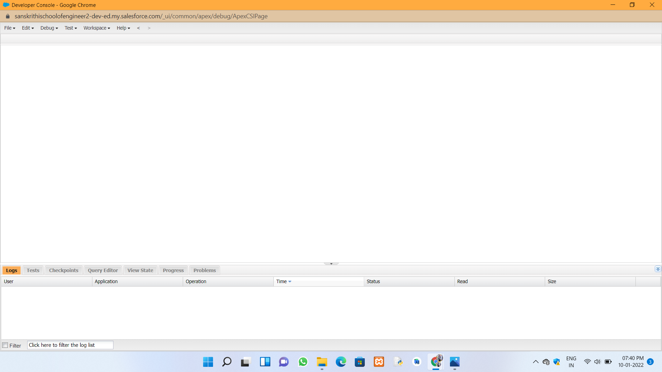

Primitive collections and datatypes :



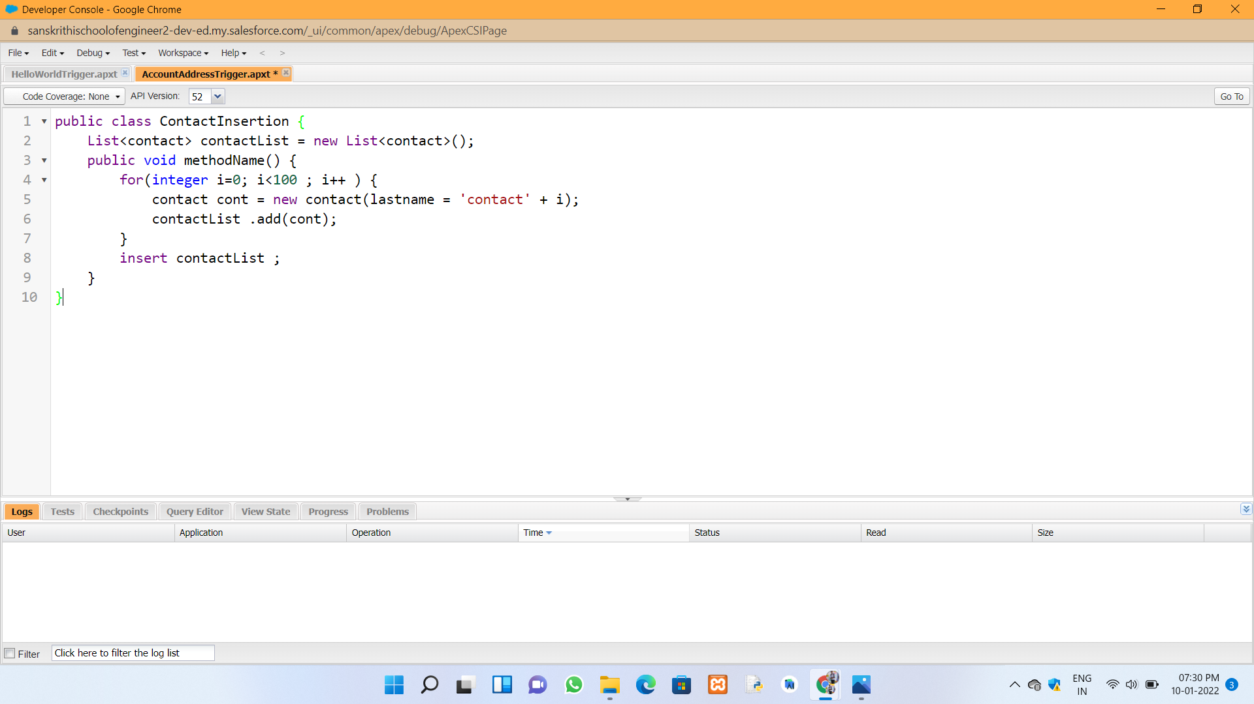

Anonymous console in developer console :





Application return values query in Developer console :



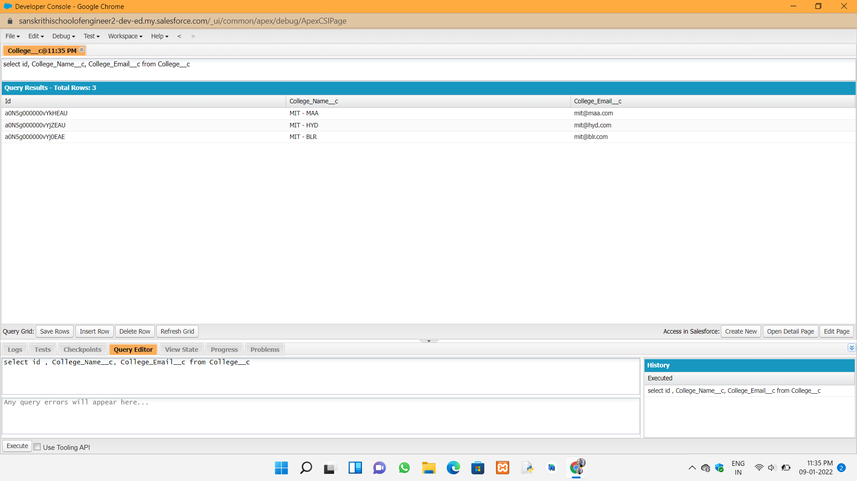

list of application form :



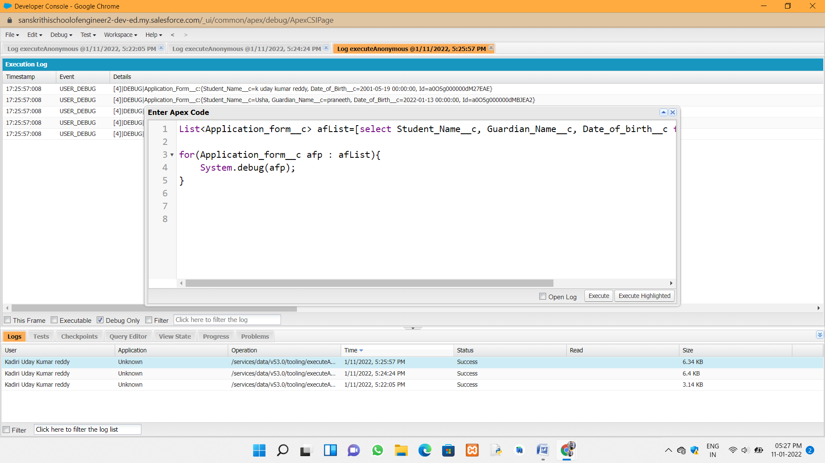



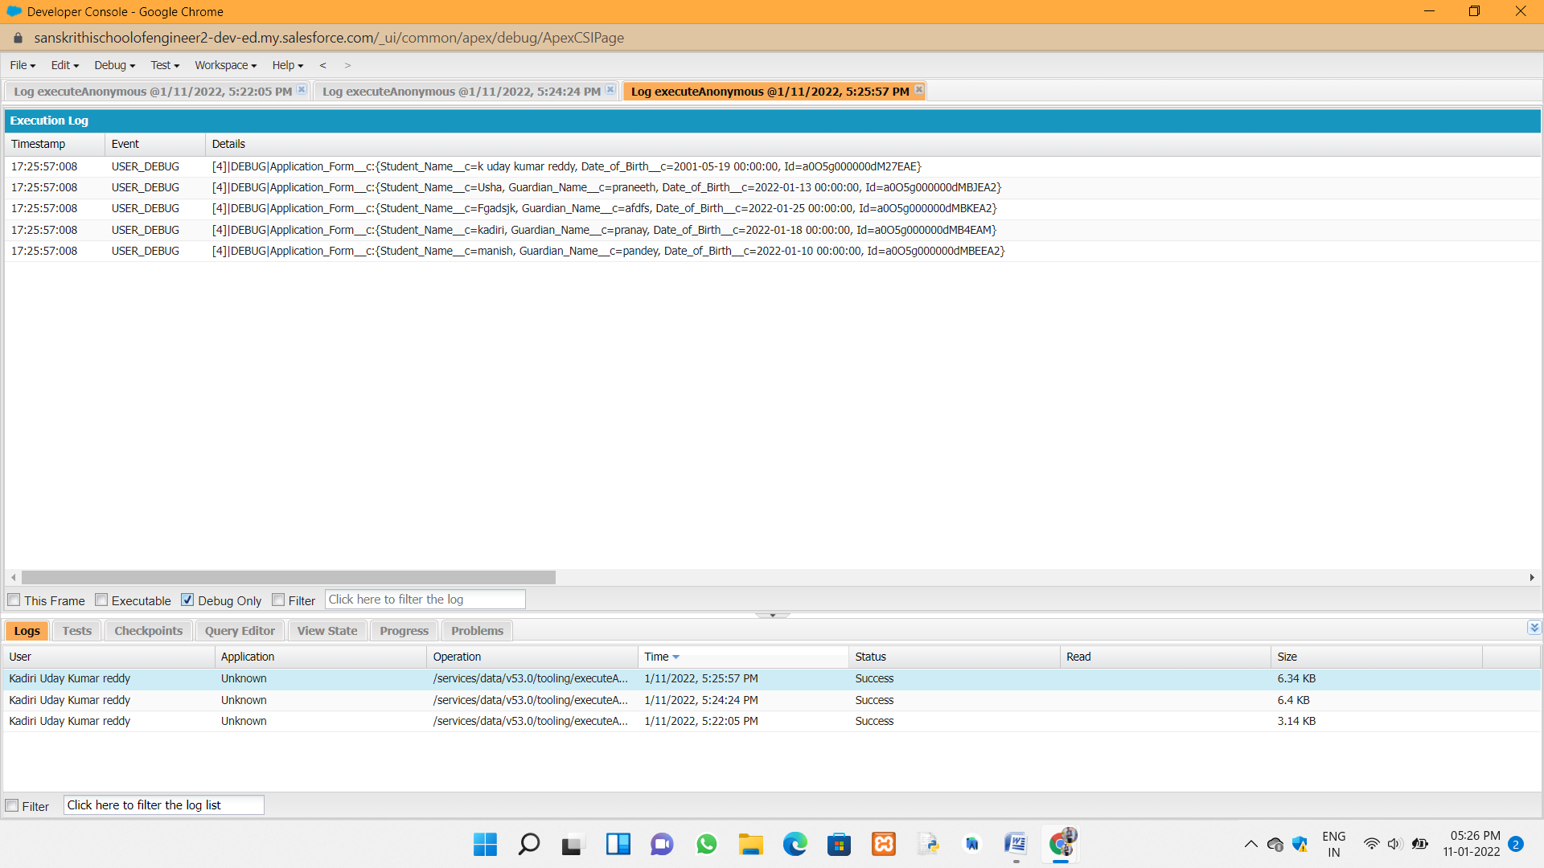

To return the account records in the account object with apex code :



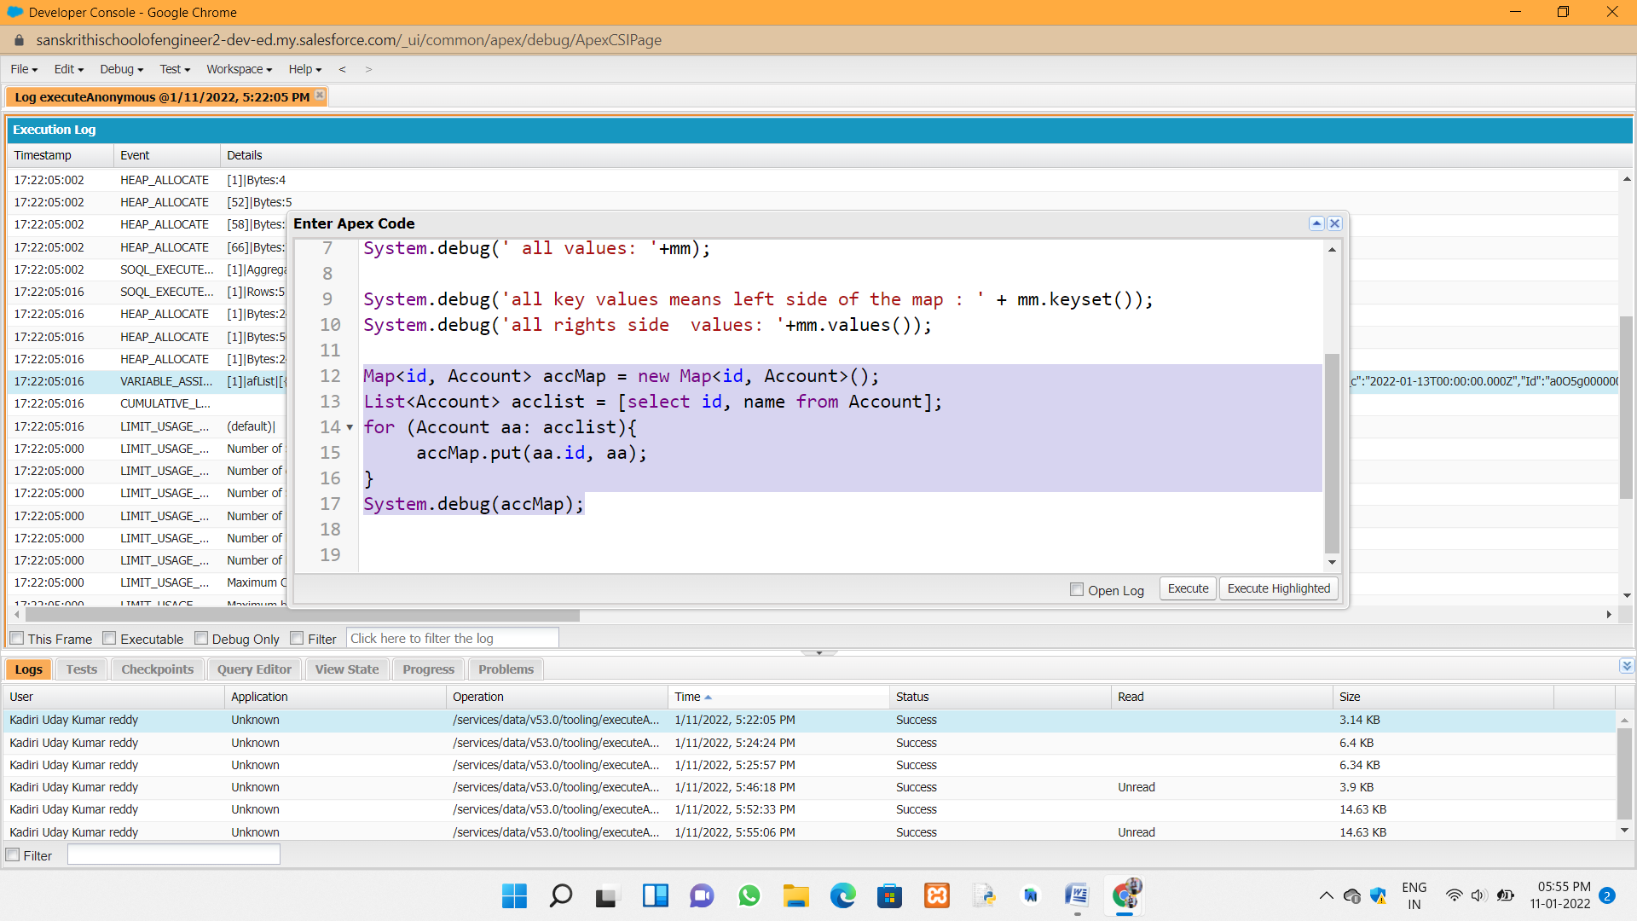



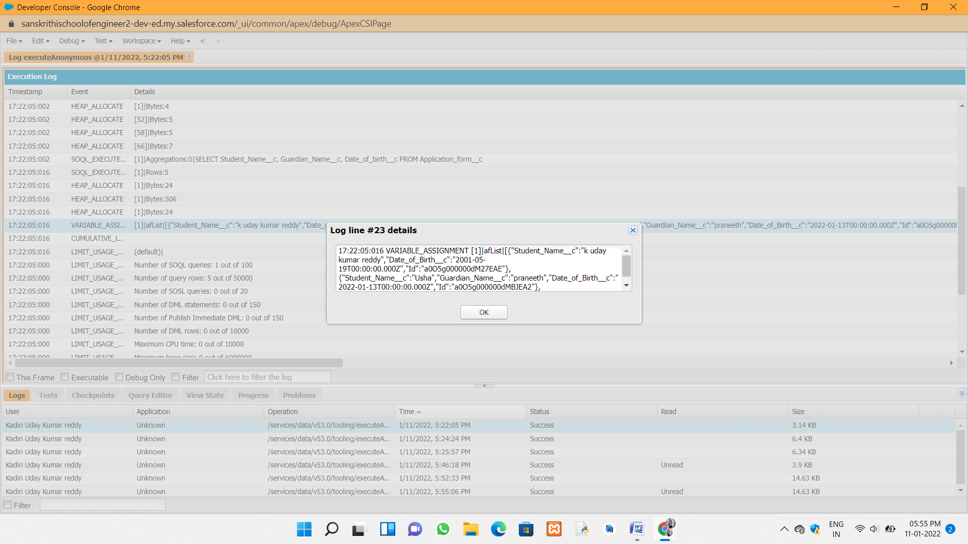

In Asynchronous Apex types :

Future method :



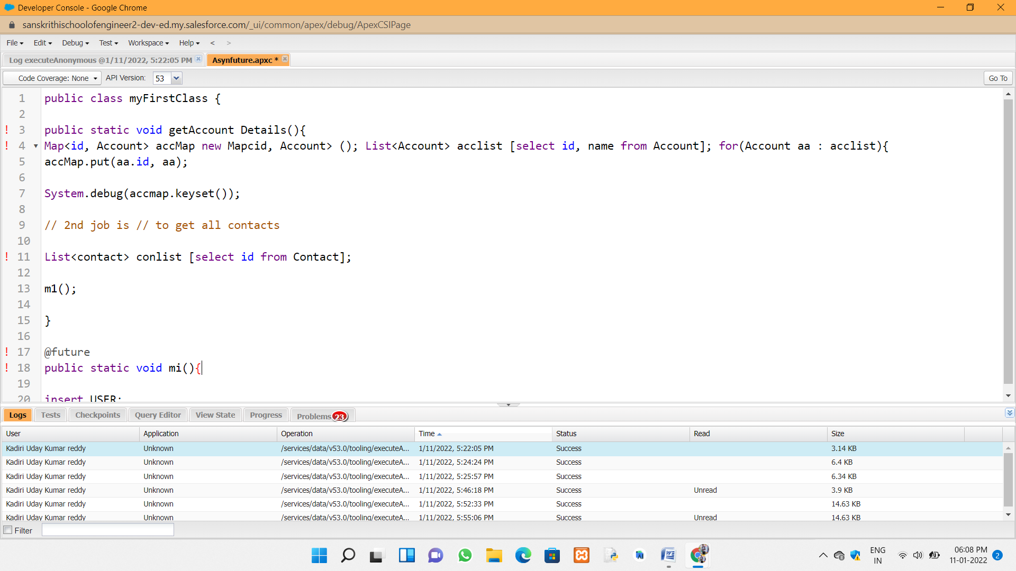



**Day 5 :**

**Topic :** Apex programming concepts

**Milestones / Activities :** Apex class and synchronous and asynchronous apex

**Description :**

**Asyncronous apex types :**

1.future method

2.Batch apex

3.Schedule apex